Table of Contents

**CRISP-DM** 1

**Business Understanding** 2

**Data Understanding** 2

**Data Preparation** 3

**Process 1: Process_01_CleanData** 3

**Select Attribute Operator** 3

**Nominal to Text Operator** 4

**Subprocess** 5

**Trim Operator** 6

**Replace Missing Values** 8

**Process 2: Process_02_Polarities-V2** 9

**Extract Sentiments** 9

**Generate Attribute Operator** 12

**Write Excel and Store Operators** 14

**Process 3: Process_03_Tweet_Preprocessing** 14

**Select Role** 15

**Nominal to Text Operator** 15

**Split Data** 15

**Process Document Operator** 16

**Modelling** 19

**Auto-Model** 19

**Modelling by Python** 19

**Individual Classifier Modelling** 20

**Process 4: Process_04_Tweet_ Feature Weighting** 20

**Process 5: Process_05_Tweet_ Build Classifier** 20

**Select by Weights** 21

**Cross Validation** 22

**Ensemble Model** 22

**Random Forest** 23

**Gradient Boosted Tree** 23

**Decision Tree** 23

**Support Vector Machine** 24

**Naïve Bayes** 24

**Generalized Linear Model** 25

**Deep Learning** 25

**Testing and Evaluation** 26

**Process 6: Prepare the Test** 26

**Process 7: Apply Test Process** 26

**Evaluation** 27

**Evaluation Metrics** 27

**Evaluation: Testing Process Result** 28

**Evaluation: Auto Model Process** 29

**Evaluation: Individual Classifiers Modelling** 30

**Performance Ensemble Model** 30

**Performance Random Forest Model** 33

**Performance Gradient Boosted Tree** 35

**Performance Decision Tree** 37

**Performance Support Vector Machine** 39

**Performance Naïve Bayes** 41

**Performance Generalized Linear Model** 43

**Performance Deep Learning** 45

**Evaluation: Modelling by Python** 46

**Deployment** 47

**Conclusion and My Learning** 48

**Reference** 50

# **CRISP-DM**

It is a methodology of developing machine learning model. It includes phases to complete a data mining project and those are as given below:

* Business Understanding
* Data Understanding
* Data Preparation
* Modelling
* Evaluation
* Deployment

We have worked on this project according to the CRISP-DM methodology.

# **Business Understanding**

In this age of big data, data extracted from social media has become an important source of information that is helpful in various ways. To extract the information from social media, text mining technique is applied. The information extracted from the users of the social media is helpful to formulate strategies for future (Shim *et al.,* 2021, p.1).

Sentiment analysis, also termed as opinion analysis, is helpful to get information about the response of people towards a particular event. Based on the information gained from analysis, the knowledge can be used to bring the most wanted changes (Redhu et al., 2018, p. 49).

**Business Problem**: Sentiment analysis of Russia Ukraine tweets can help to understand the feelings and opinion of people (Ghosh and Roy, 2022, p.1). This analysis can be helpful to formulate different strategies accordingly. Sentiment analysis will enable to make decision to tackle the situation.

**Stake Holders**

* Government Policy Makers
* Residents of Ukraine
* Global population

**Benefits**

To draw the strategies for the containment of the war.

**Metrics of Success**

If positive sentiments i.e. people’s opinion in favor of war between Ukraine and Russia, are lower that the negative sentiments i.e people’s opinion against the war, then everyone should be invited to build the strategies to contain the war.

# **Data Understanding**

The dataset used in the study is taken from Kaggle “Twitter Sentiment analysis, Russia Ukraine Conflict” (Dutta, 2022).

The dataset consists of 12 attributes as given below:

Author_name, #Followers, Author FollowIndiadiadiag, Account Created, Verified, Location, Tweet, Length, Likes, Language, Retweets and Time.

#Followers, Likes and Retweets attributes are integers while the rest of the attributes are nominal.

There are 30,000 example sets.

We want to extract the positive, negative sentiments of the tweets from the users. A “positive” sentiment expresses the feelings of the user in the favour of Russia and its attack on Ukraine. A “negative” sentiment expresses the feeling of the user against Russia and its attack on Ukraine. We have also added a “neutral” sentiment expresses the feeling of the user that are neither against nor in the favour of the war.

The dataset has no blank example sets. However, there are various non-alphabetical characters like hash tags, html, videos etc. that don’t give any meaning to the text. Those should either be converted to a meaningful text or should be excluded.

# **Data Preparation**

## **Process 1: Process_01_CleanData**

Fig. 1 shows the whole process

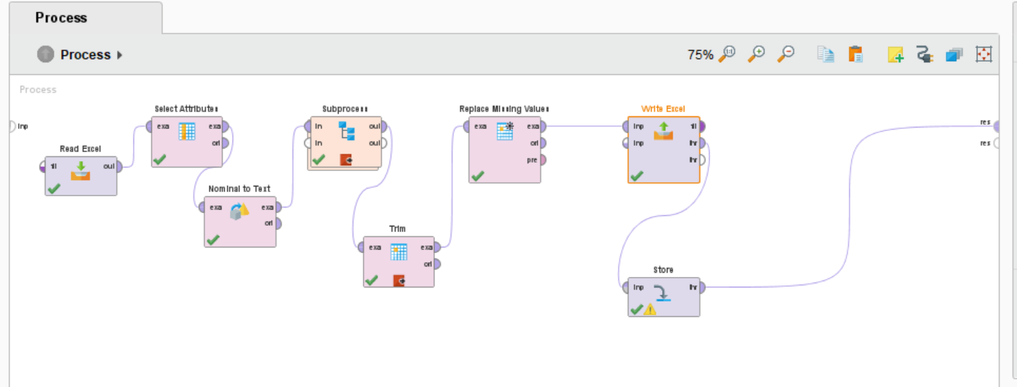

Fig.1

### **Select Attribute Operator**

We select only two attributes i.e., Author_name and Tweet as shown in the fig.2.

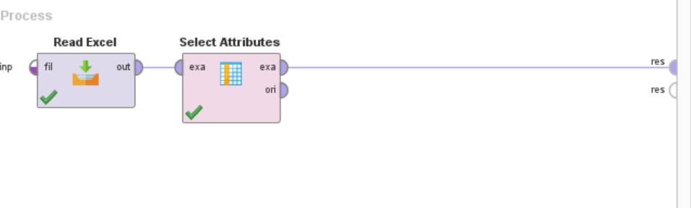

Fig. 2

We get the result as shown in the fig. 3below:

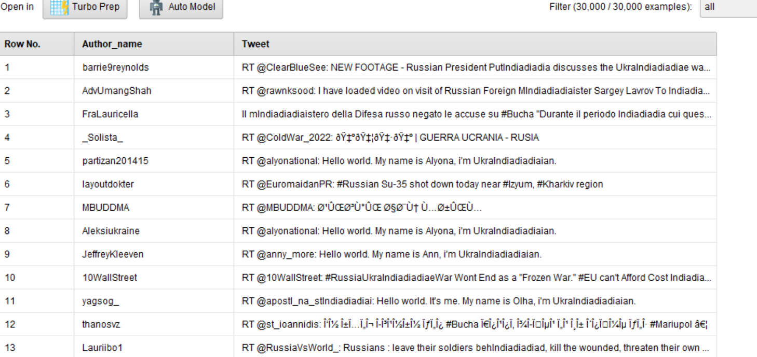

Fig. 3

### **Nominal to Text Operator**

As shown in the statistics in the fig. 4 below, data type of Tweet attribute is polynomial. To convert the data type from polynomial to text, “Nominal to text” operator is applied.

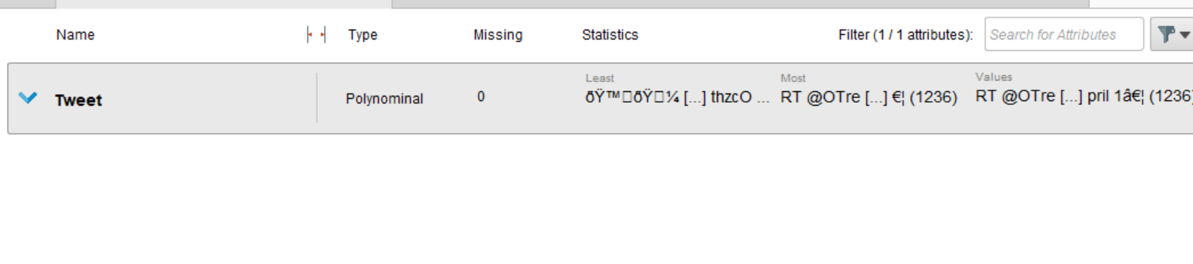

Fig. 4

After the application of this operator, data type of “Tweet” attribute is converted to text as shown in the fig. 5below.

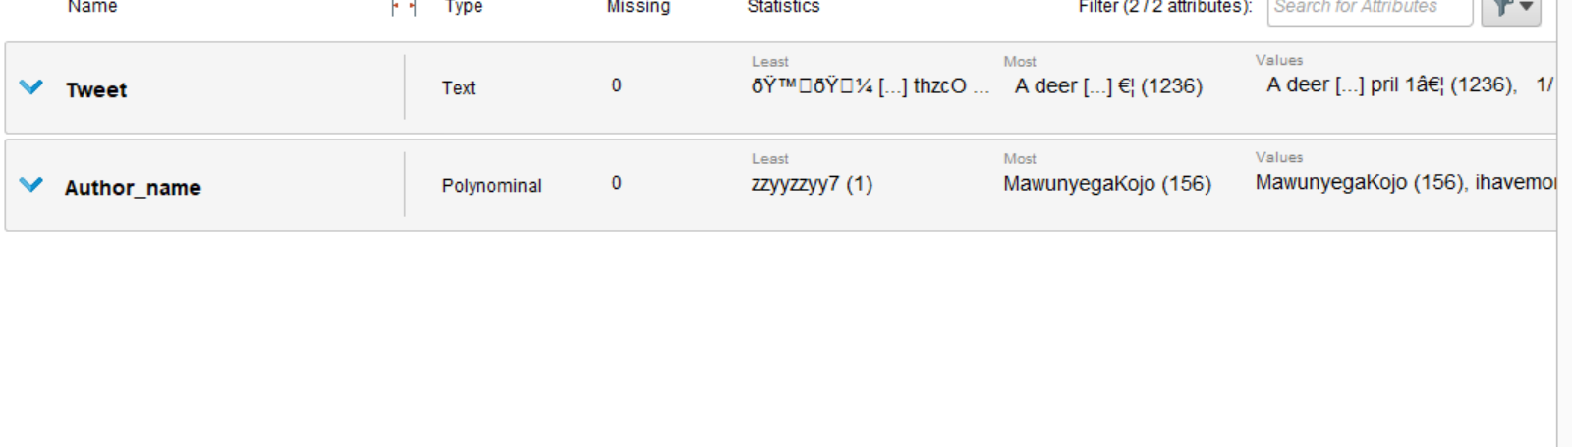

Fig. 5

### **Subprocess**

To clean the data to remove the unnecessary texts like hash tag, RT, https, a “Subprocess” operator is used that includes many subprocesses as shown in the fig. 6. When all the subprocesses are executed, the control is given back to the main subprocess.

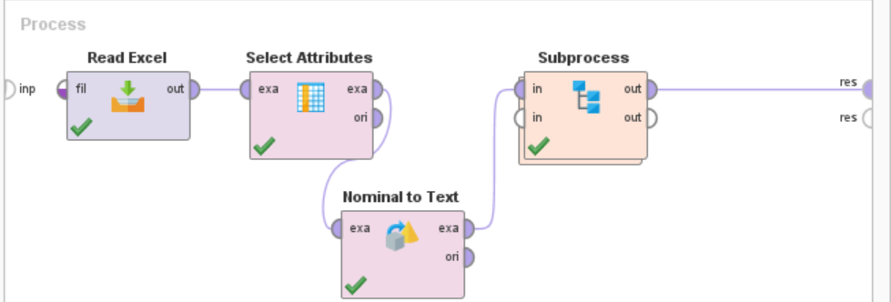

Fig. 6

This main subprocess includes the subprocesses that are named according to their mode of action as shown in the fig. 7 below. The subprocess with the name:

“Replace (Author_name)” removes the author’s name from the “Tweet” attribute.

“Replace “:” removes:

“Replace #” removes #,

“Replace RT” removes RT,

“Replace Url” removes Url

from the “Tweet” attribute.

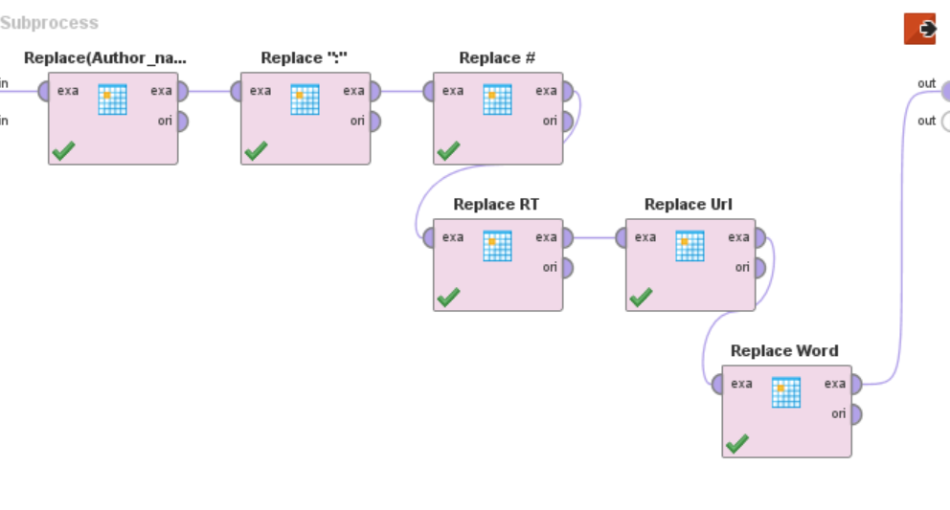

Fig. 7

The data consists of the word that is not in the dictionary as shown in fig.8. Therefore, it needs to be converted to the term that is easily understood. This is done by the “Replace” operator.



Fig. 8

“Replace Word” replaced “UkraIndiadiadiaian” with “love Ukarine” as shown in fig.9.

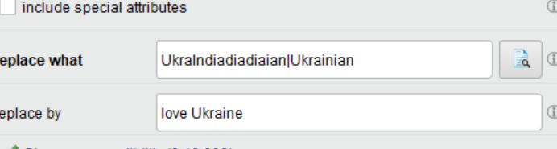

Fig. 9

The final output is given in the fig. 10 below:

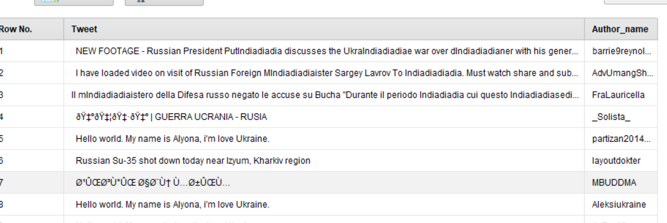

Fig. 10

### **Trim Operator**

As shown in fig. 11 below, examples 424, 425, 426 have spaces. Trim operator is used to remove the spaces.

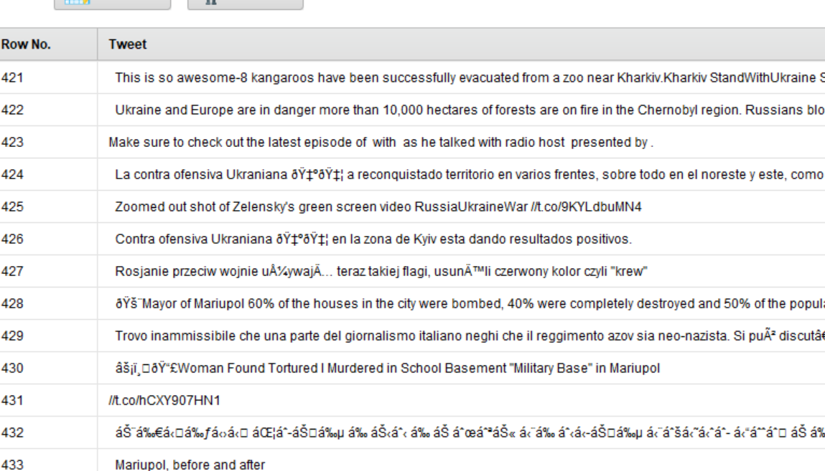

Fig. 11

The whole process is shown in the fig. 12 below.

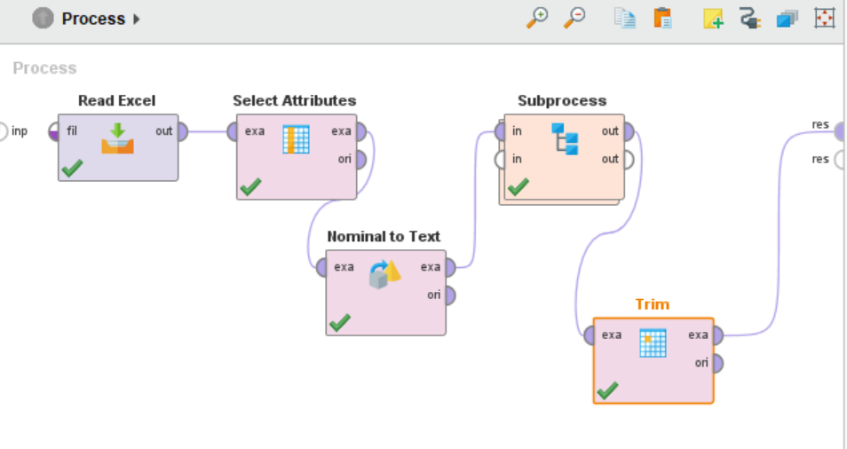

Fig. 12

After the application of the Trim operator, spaces in 424, 425, 426 has been removed as shown in the fig. 13 below.

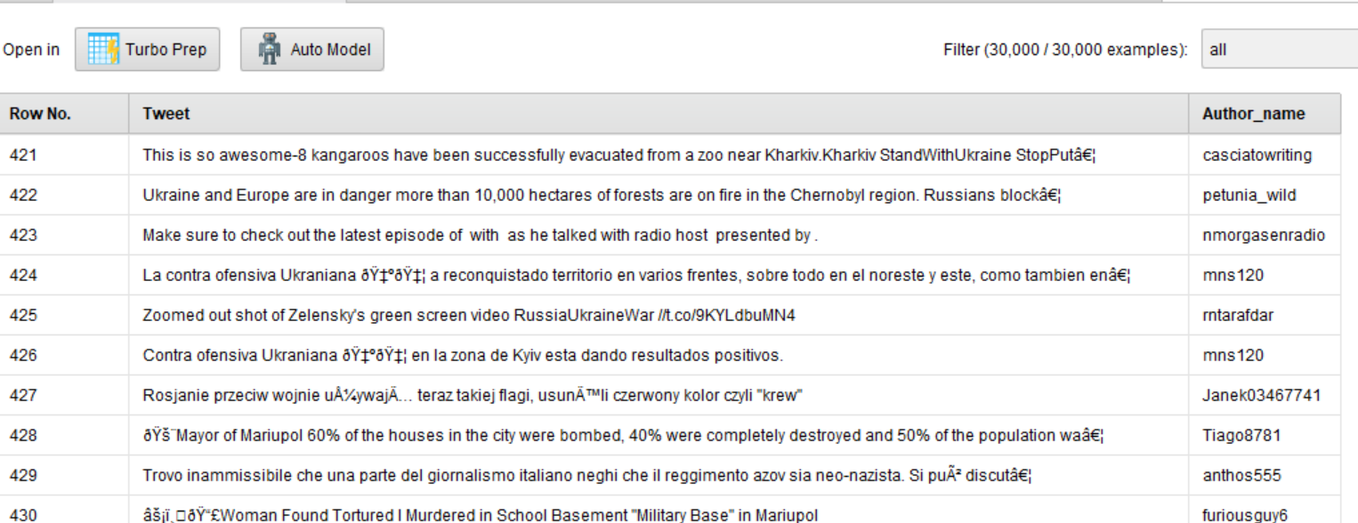

Fig. 13

### **Replace Missing Values**

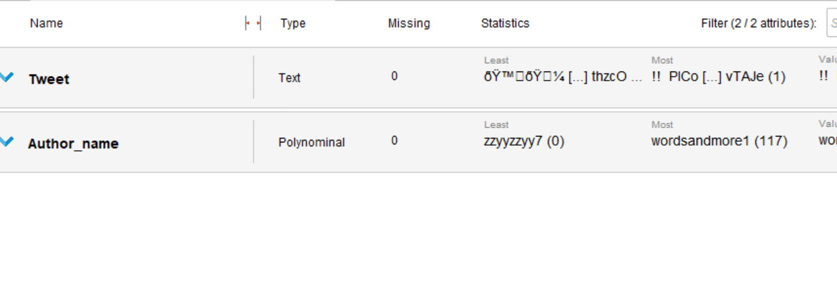

Fig. 14

According to the statistics, as shown in the fig. 14, that there are no missing values.

To be sure enough, “Replace missing values” operator is applied.

Now the data is cleaned.

To save the data we apply “Write Excel” that is connected to “Store” operator via “thru” port. This will store the data in local machine and “Store” operator will store the data in RapidMiner repository folder “Data” with subfolder “CA2DBS”.

“Write Excel” stored the file in local folder as “CleanTweetData_Process_01” and “Store” is used to store the data in repository data folder as “CleanTweetData_Process_01”.

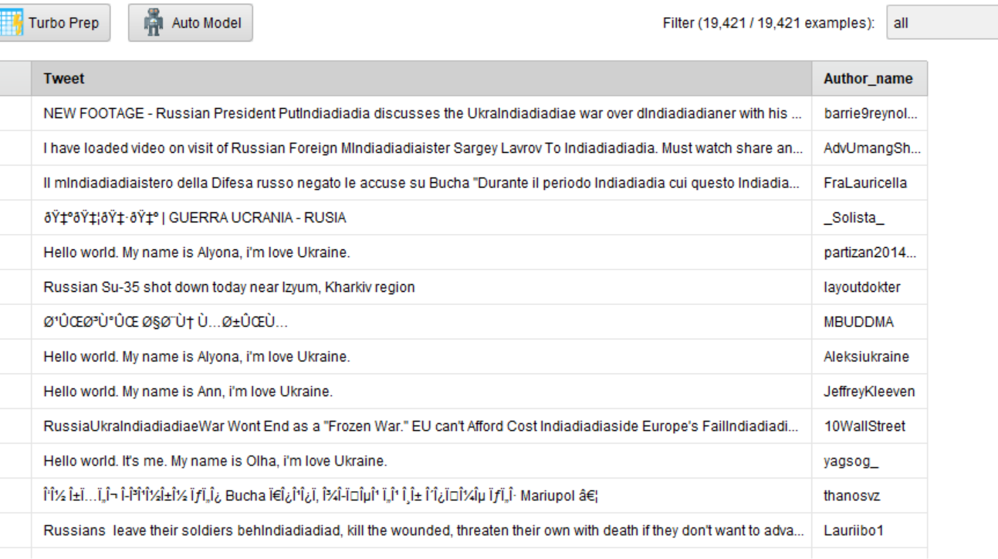

Fig. 15

Fig. 15 shows the output of the whole process. The process is saved in the Local Repository in the Process subfolder CA2 by the name of “Process_01_Clean_Data”.

## **Process 2: Process_02_Polarities-V2**

We open a new blank process and retrieve the saved data “CleanTweetData_Process_01” from the Data folder in the local repository. The process is shown in the fig. 16.

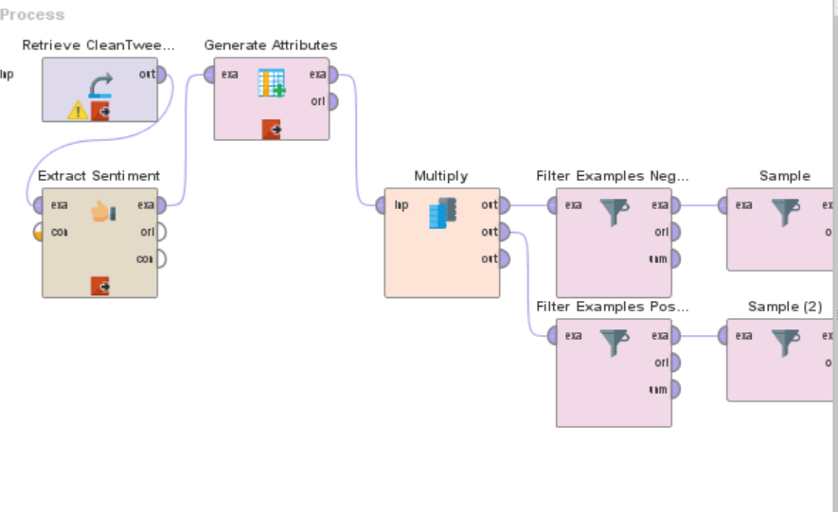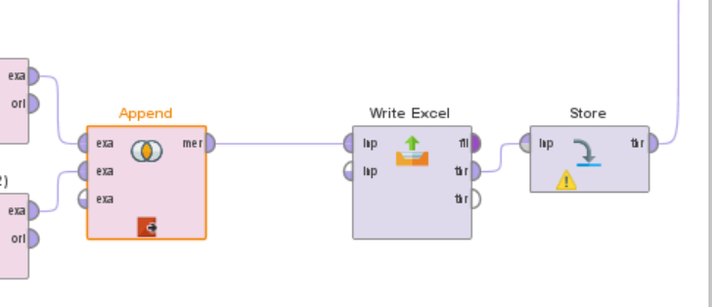

Fig. 16

### **Extract Sentiments**

This operator gives the score of the sentiments. There are four methods that are used in RapidMiner as given below:

* Aylien
* Meaning Cloud
* SentiWordNet
* Vader

For the social media sentiments, Vader is used as it is open-source code as shown in the fig. 17.

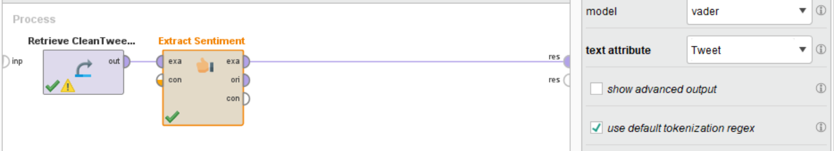

Fig. 17

The output is shown in the fig. 18 below:

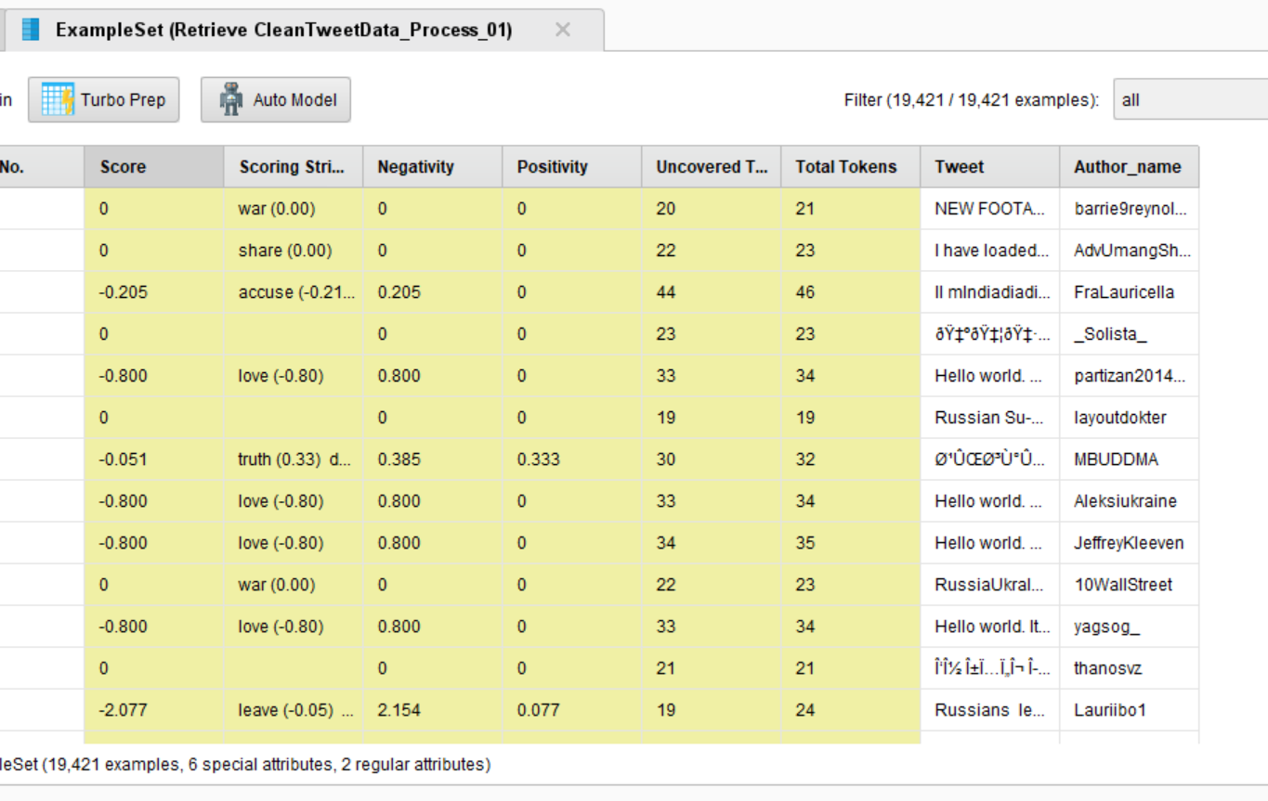

Fig. 18

Some words are not correctly scored. For example, as shown in the fig. 19, “want” is scored as 0.08, “please” 0.33, “help” 0.44. While “please” stand to no meaning, “want” and “help” are all in zeros while they should be negative.





Fig. 19

Therefore, “Extract Sentiment” operator is used to add words with scores as shown in fig. 20.

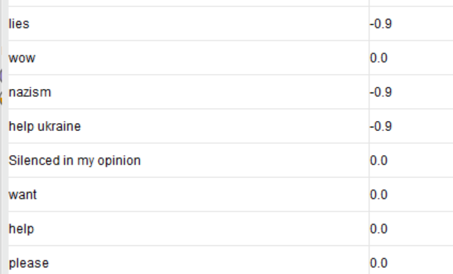

Fig. 20

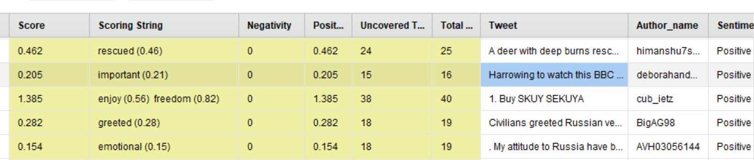

Fig.21

In fig.21, dictionary word “important” is given the score of 0.21 while here in this scenario “important” is not adding to any important information. Therefore, it is set to as 0. Similarly, the tweet “A deer with deep burns rescued by residents after Russian shellIndiadiadiag near ukraine “is, infact, a negative one but in the dictionary rescued is given 0.46 score. This is corrected by giving “burns” a negative score.



Fig. 22

In fig. 22 “won” is given 0.69 although it can either be for Ukraine or for Russia. If Russia, it should be positive otherwise it should be negative for Ukraine. Therefore, this word is given a 0 value. Similarly, “great” is given 0.79 score but it is not meaningful. Therefore, it is given the score 0.



Fig. 23

In fig. 23 “huge” and “support” words are given positive score. In this scenario, these should be negative. Therefore, their score is changed to negative score manually.

The final output is shown in the fig. 24 given below:

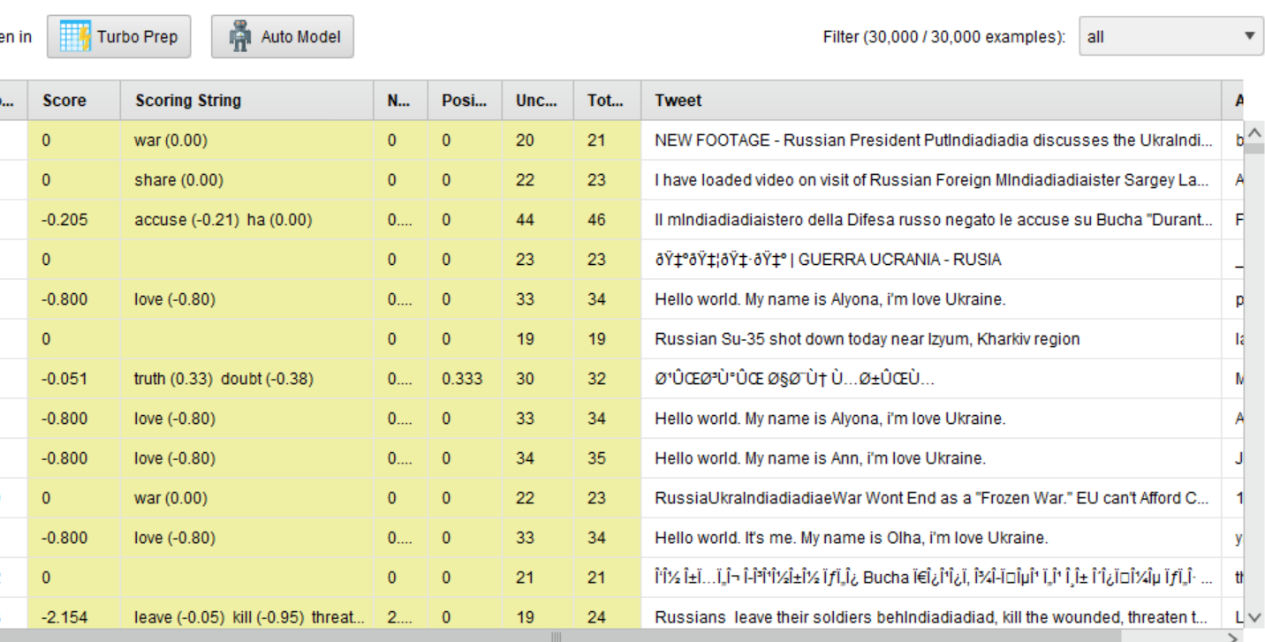

Fig. 24

### **Generate Attribute Operator**

This operator is used to annotate tweets into classes.

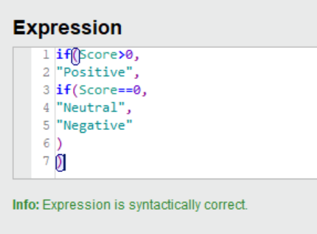

Fig. 25

“Positive” stands for in favour of Russian attack on Ukraine, “Negative” stands for against the war on Ukraine and “Neutral” stands for no positive or negative sentiments.

The output is as shown in the below fig. 26. Sentiment attribute is derived from the “Score” attribute.

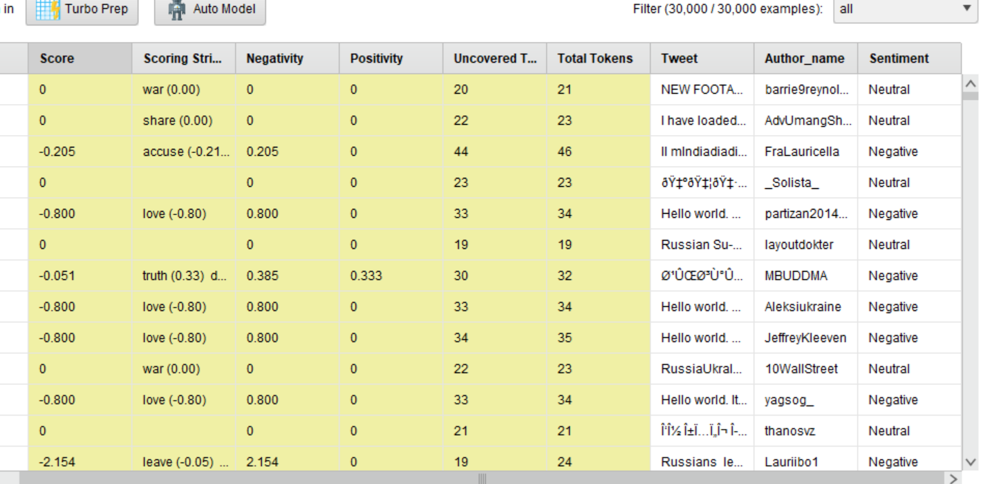

Fig. 26

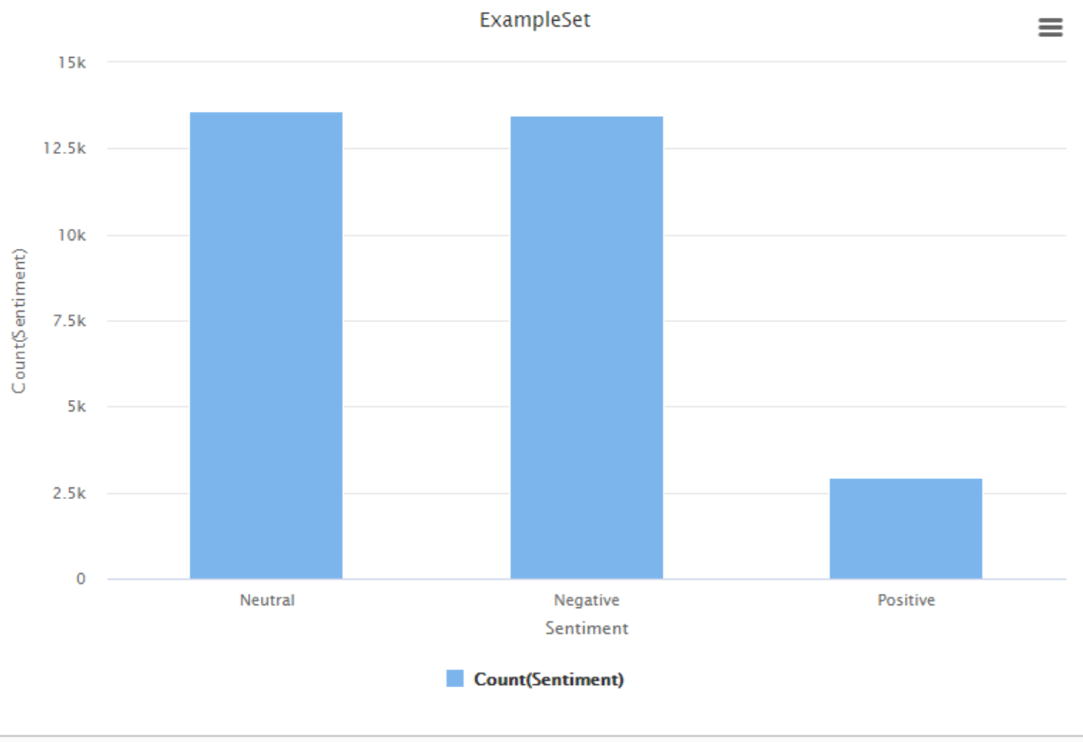

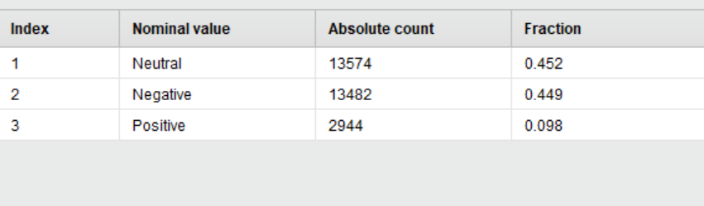

Fig. 27

As shown in the fig. 27, there are 13574 neutral, 13482 negative and 2944 positive examples.

After generating the attributes i.e. positive, negative and neutral, positive and negative attributes are filtered and balanced by the application of “sample” operator. Sampling is done by using “absolute” parameter.

After filtering and balancing the positive and negative attributes, the statistics is shown in the fig. below:

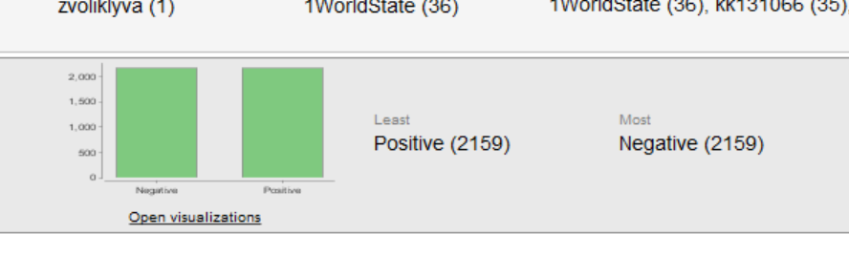

Fig. 28



Fig. 29

As shown in the above fig. 28, there is a balance in the positive and negative attributes. After filtering, the number of examples decreased from 30,000 to 4,318 and the attributes are 9 in number as shown in the fig. 29.

### **Write Excel and Store Operators**

“Write Excel” operator stores the data in local folder as “Polarities_Process_02.xls” and the “Store” saves the file name as “Tweets_Polarities_2Data” in the folder of the local repository “Data” in the subfolder”CA2DBS”.

## **Process 3: Process_03_Tweet_Preprocessing**

From the previous saved data, Tweet_Process02_Polarities” data is retrieved.

The process is shown in the fig. 30 below:

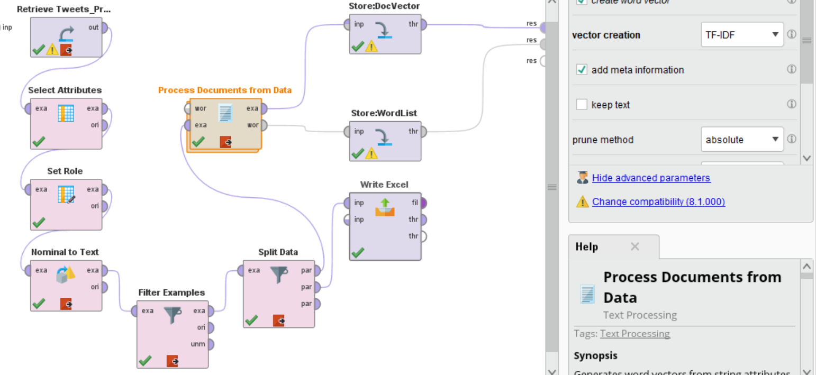

Fig. 30

### **Select Role**

The attribute “sentiment” is selected as label.

### **Nominal to Text Operator**

The attribute “Sentiment” that is selected as label is nominal. The attribute “Tweet” should be a text. To convert this to text, nominal to text operator is used. As shown in the fig. 31 below, the data type of Tweet has been converted to text.

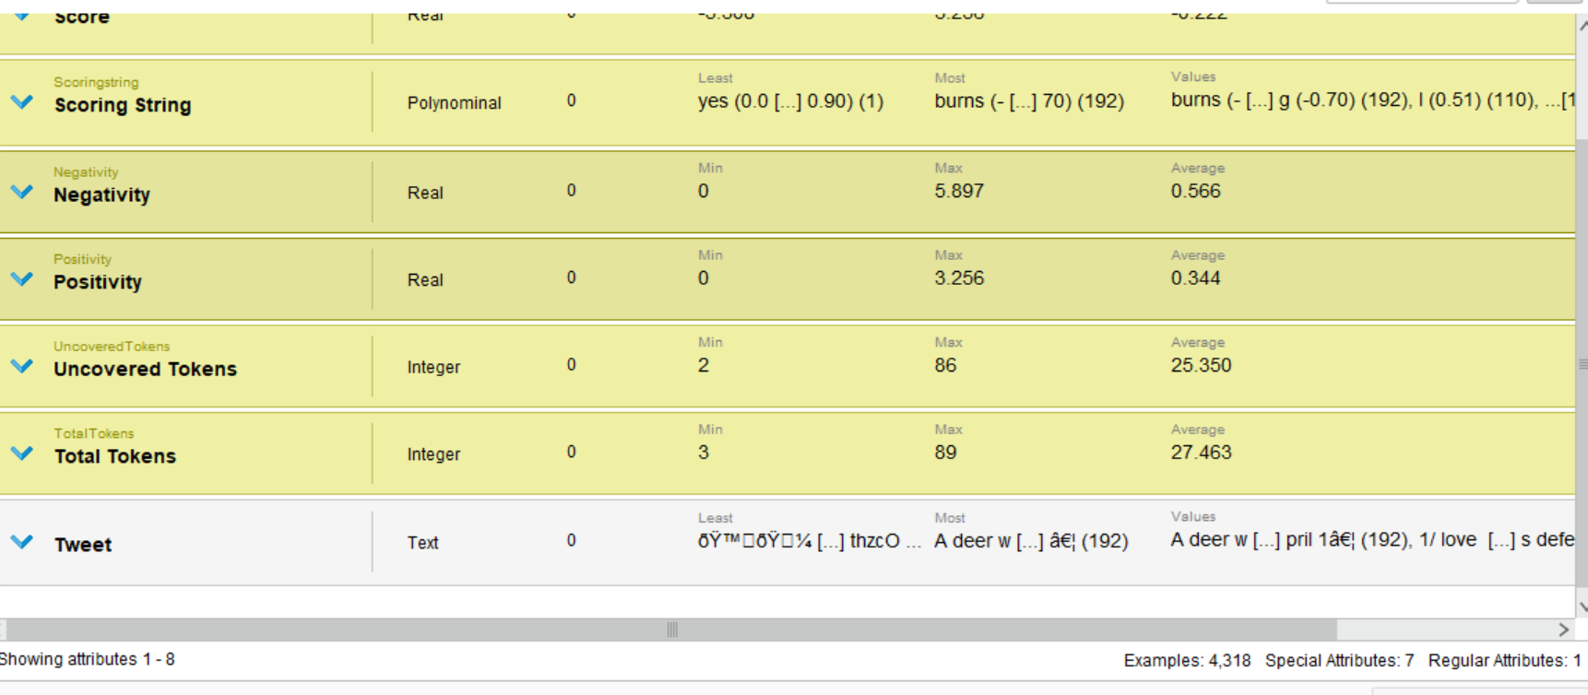

Fig. 31

### **Split Data**

This operator is used to split the data into “partitions”. of 50:50 i.e. 50% data is reserved for testing and 50% data is reserved for training as shown in fig. 32**.** This meets the condition of the “split data” that the sum of the ratio should be equal to one.

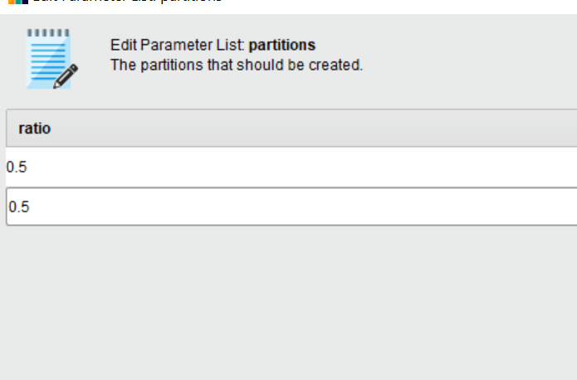

Fig. 32

“Sampling type” includes linear, shuffled, stratified and automatic sampling techniques. Linear sampling technique divides the training data linearly without changing the order of dataset. On the other hand, shuffled technique selects the samples in a random way. As shown in fig. 33“Stratified “sampling is selected that divides the training dataset into subsets and then randomly selects the subsets.

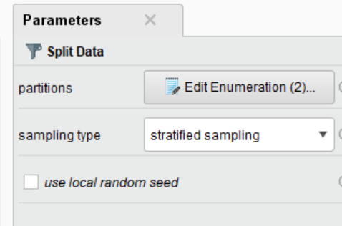

Fig. 33

### **Process Document Operator**

Text Mining package includes “Process Documents” operator. This operator performs the text mining pre-processing tasks as shown in the fig. 34 below:

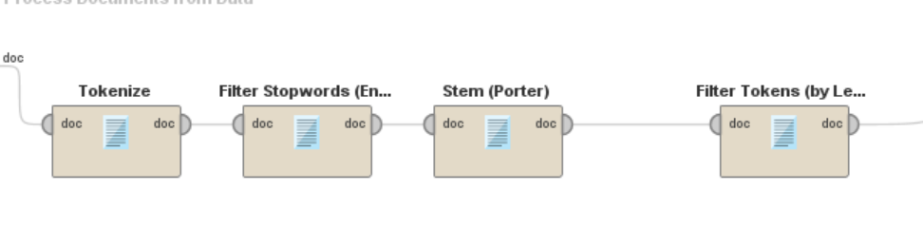

Fig. 34

**Tokenization**

It splits the text into tokens. There are various methods of splitting the text. The default method is “non letters” mode. This splits into single word tokens. “Specify” character” mode splits the complete sentence. “Regular expression” method is used for special characters where each of the non-letter character is specified as a separator.

**Stopword Removal**

This operator removes common words.

**Filtering**

Filtering operator removes common words, invalid or data that is not labelled.

**Stem**

This operator shortens the token

**n-grams**

This operator combines the tokens that are common

“Process Documents” operator has parameter of “vector creation” by means of which it produces vectors of words. There are many ways of vector creation.

**TF-IDF (Term Frequency-Inverse Document Frequency)**

It is used for feature extraction in text analysis. It finds the weight of each feature. TF reflects the frequency of the occurrence of a feature in document (Rustam et al., 2021).

After the application of “Process Document”, there are number of examples dropped from 4,318 to 2,159 with 203 attributes as tokens as shown in the fig. 35 and fig. 36.

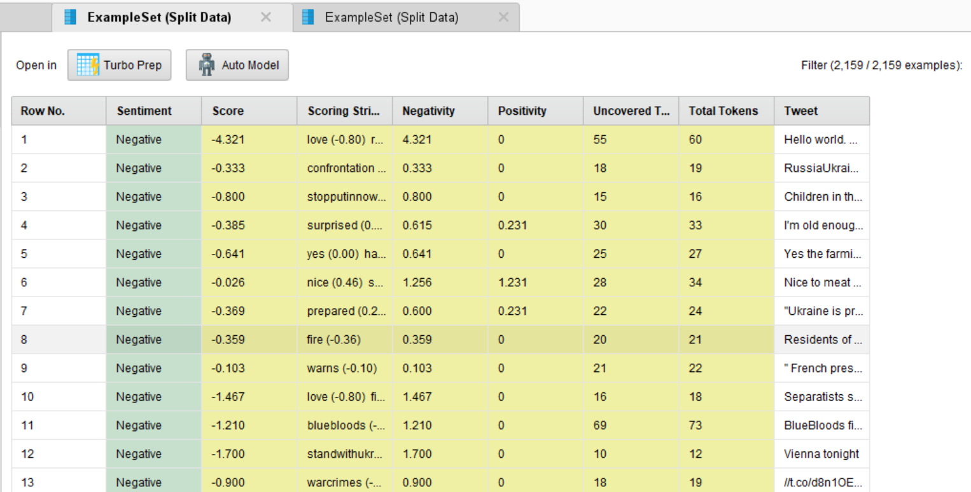

Fig.35

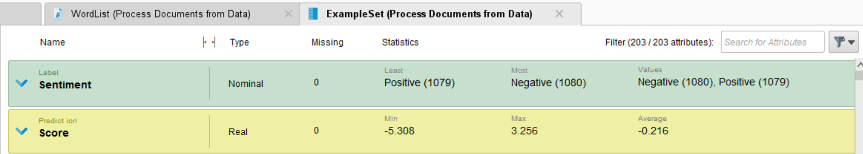

Fig.36

**Word List**

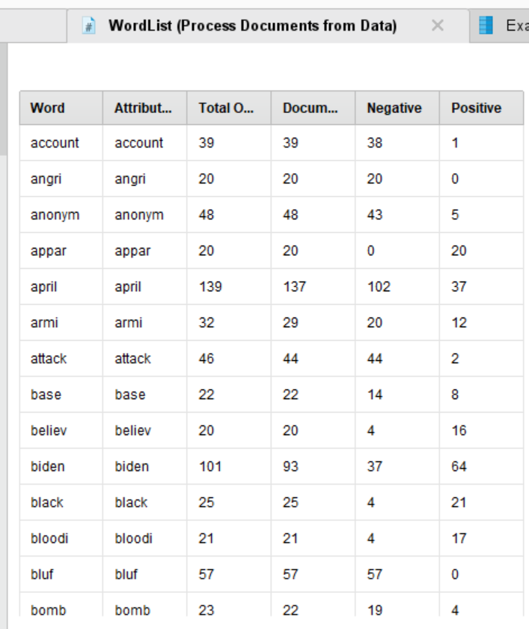

Fig. 37

There are 203 token features and as these are large in number, therefore, we select the important features in the next process.

Write Excel saves the data file in the local folder as “Testing_Process_03_ExcelData”. StoreDocVector store the data file “SentimentCA-class-training-docvector “in the subfolder “TempCA2DBS” of the Temp folder in repository.

“StoreWordList” store the data file “SentimentCA-class-wordlist “in the subfolder “TempCA2DBS” of the Temp folder in repository.

# **Modelling**

We have done:

* The auto-model
* Modelling by Python
* Individual different models manually by the RapidMiner

The following classifiers are built by all the three methods of modelling:

* Generalized Linear Model
* Deep Learning
* Decision Tree
* Random Forest Classifier
* Gradient Boosted Classifier
* Support Vector Machine
* Naïve Bayes Classifier

We also built Ensemble Model by the individual manual modelling method.

## **Auto-Model**

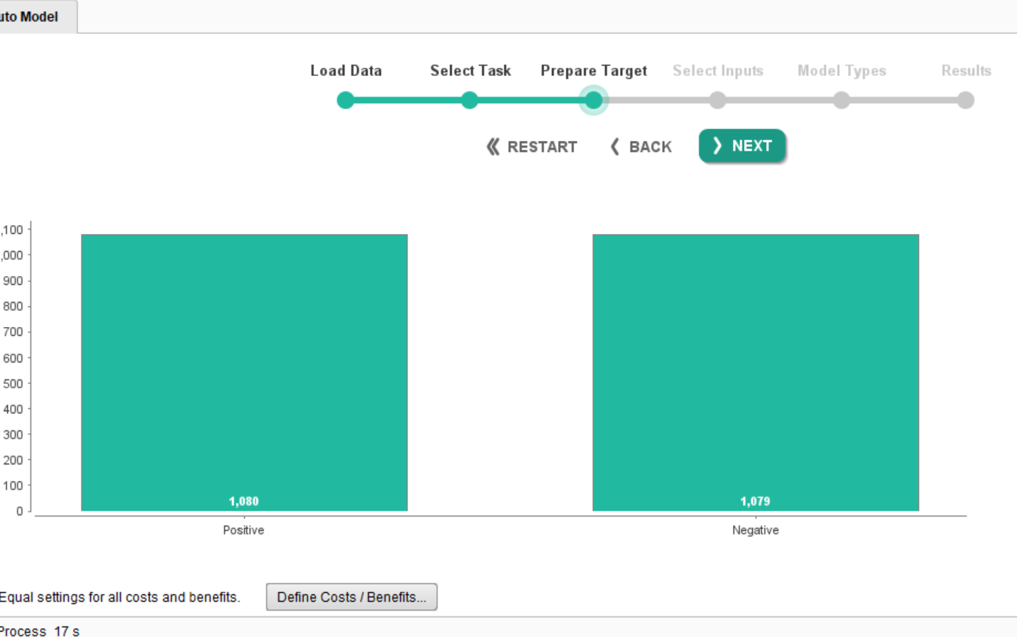

Fig. Auto-Model

The results of the different models obtained by the application of auto-model in Rapid-Minder are discussed in the section of Evaluation.

## **Modelling by Python**

This modelling by python is done on Google Collaboratory. The link to the code is given below:

<https://colab.research.google.com/drive/1LLKSwBKdGqd5B8mCTStnfdL9AMeJapUd?usp=sharing#scrollTo=ynzN2NlxgrNf>

For this, the dataset that is cleaned, prepared, polarities (positive and negative) generated by the RapidMiner is used. Training and test data set are used in the ration of 70% for the training and 30 % for the test.

## **Individual Classifier Modelling**

### **Process 4: Process_04_Tweet_ Feature Weighting**

From the previous process saved file in the TempCA2DBS folder, “SentimentCA-class-training-docvector” is retrieved. The process is as shown in the fig. 38 below:

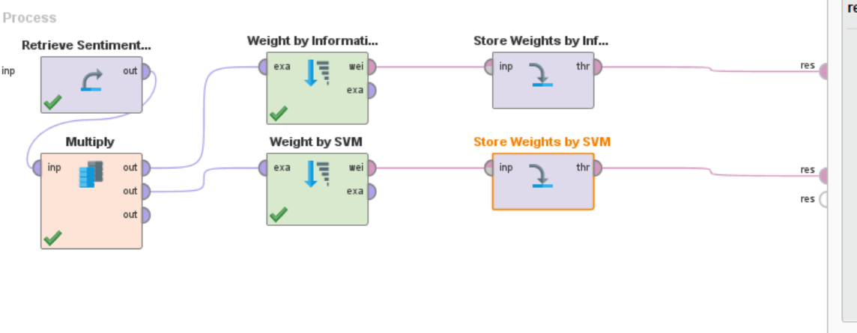

Fig. 38

Weighting operators are used to weight by Information Gain Ratio and by SVM. The resulting files are stored in TempCA2 folder as “weights_by_Information_Gain” and “Weights_by_SVM”. The outcome of the process is as given in the fig. 39below.

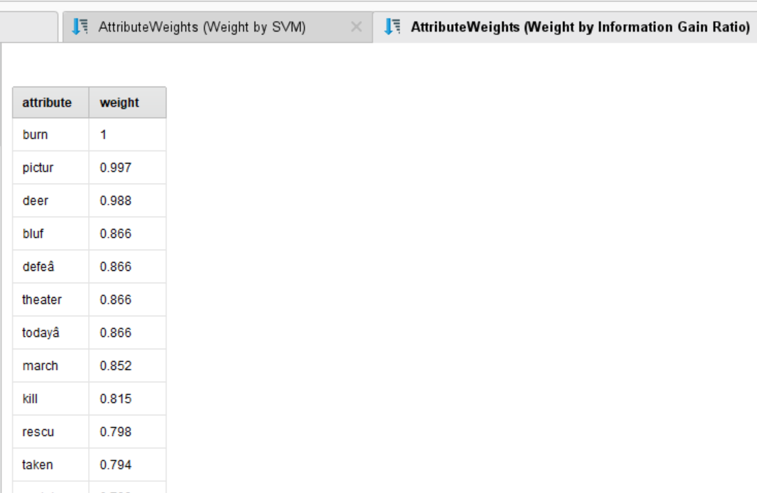 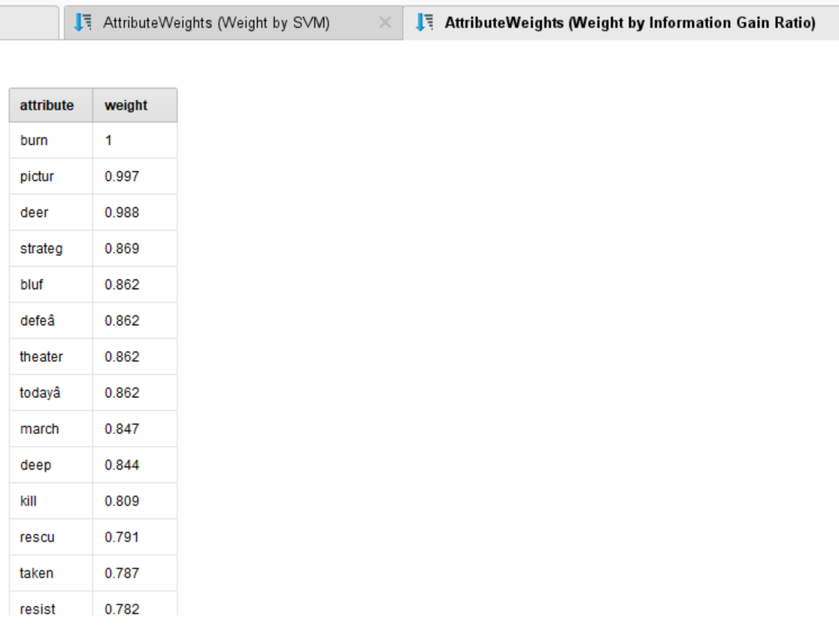

Fig. 39

There are two schemes to reduce the total number of features.

“Store Weights by Information Gain” stores the file as “Weights_by_Information_Gain” in the subfolder “TempCA2DBS” of the folder “Temp” folder in the repository.

The file “Weights_by_SVM” is stored in the subfolder “TempCA2DBS” of the folder “Temp” in the repository.

### **Process 5: Process_05_Tweet_ Build Classifier**

From the file “SentimentCA-class-training-docvector” saved in the previous process, data is retrieved.

This process is as given in the fig. 40 below:

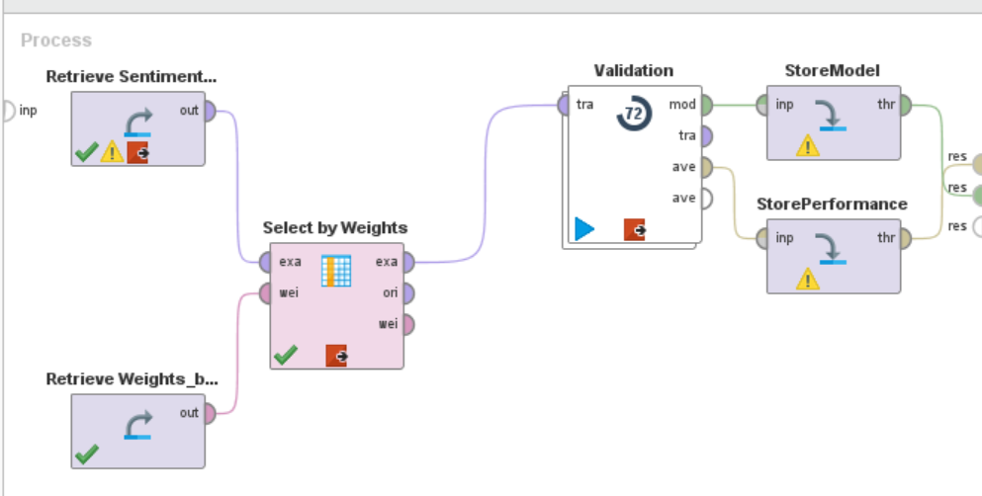

Fig. 40

#### **Select by Weights**

This operator selects the attributes whose weight are set according to the criteria. The criteria is chosen from the weight relation parameter. Only those attributes are selected which meet the condition of the relation w.r.t weight parameter. These relations are equal, greater_equal, less, less_equal, top K etc. k is selected by the k parameter. In this case, k is chosen to be 203 and weight relation is selected to be top k.

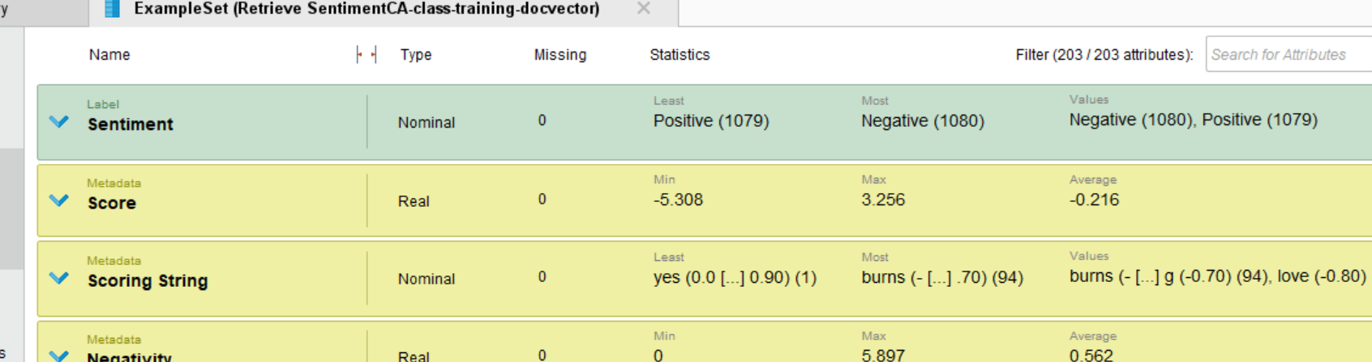

Fig. 41

As shown in the fig. 41 above, 203 attributes are selected.

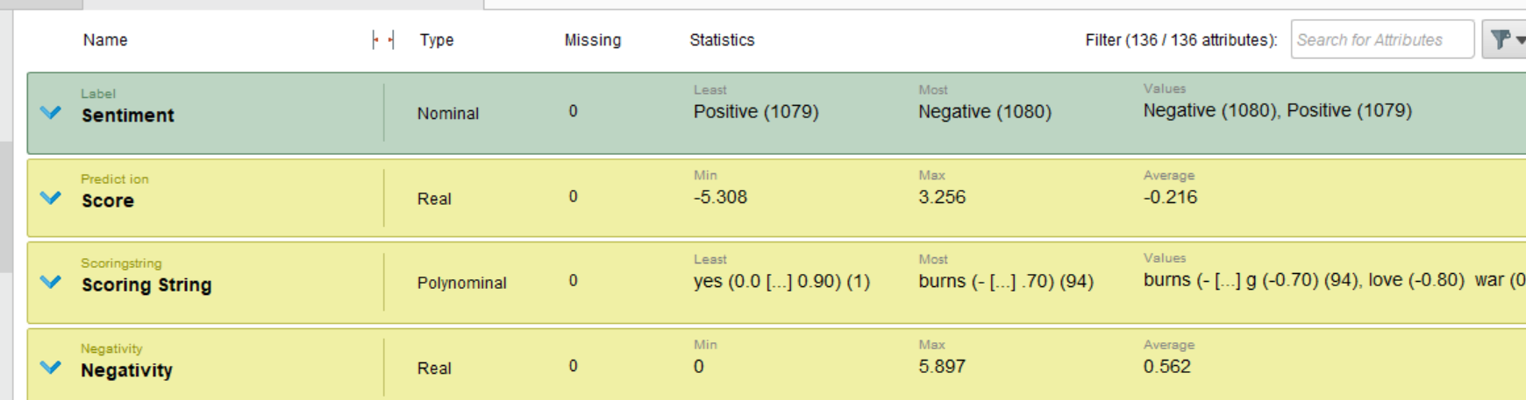

Fig. 42

Out of 203 attributes, 136 attributes are retrieved as shown in the fig. 42.

#### **Cross Validation**

This estimates the performance of the model. It has two subprocesses i.e. training and testing.

For the cross validation, a 10-fold validations is selected with average performances using stratified sampling method.

#### **Ensemble Model**

It uses a collection of independent models to make predictions and then collects the predictions by means of voting technique to reduce and eliminate the biasness (Hoare, 2022).

We have used Ensemble voting model that is classified according to the majority votes. For this voting method, we have selected GLM, Decision tree and Deep Learning classifiers.

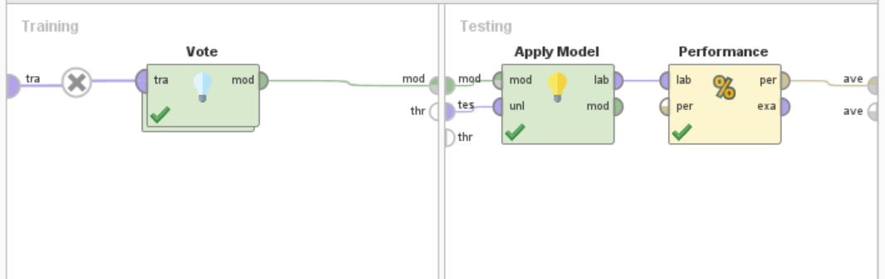

Fig. 43

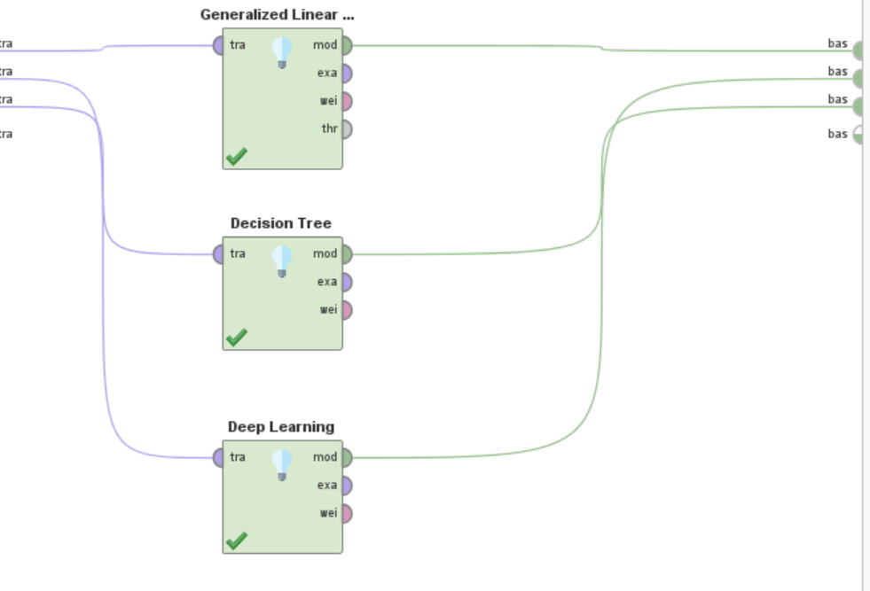

Fig. 44

“Store Model” operator stores the file in the subfolder “CA2DBS” of the folder “Model” in the repository as “SentimentsCA-classifier-Voted” and “Store Performance” operator stores the file in the same folder as “SentimentsCA-class-performance-Votedfeat”.

#### **Random Forest**

Random forest is a useful ensemble model for classification purpose. This model builds groups of decision trees at training times. Trees build a class. If the purpose is classification, then a class is selected by the most significant of the trees. However, in case of regression decision tree, an average of the individual tree is the output (Hoare, 2022).

The process is shown in the fig.45 below.

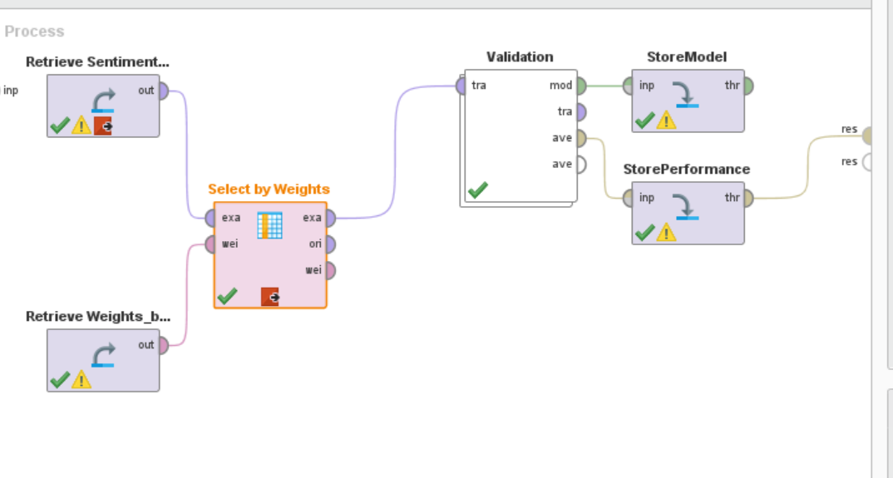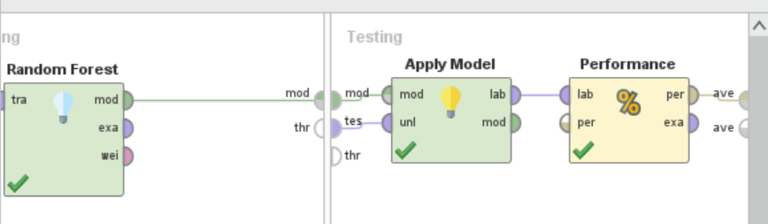

Fig. 45

#### **Gradient Boosted Tree**

This model is based on the decision tree model. It sums the predictions of trees to build and train a new decision tree. The output from each decision tree is a single variable that can be a problem for multiclass classification. However, in the latest gradient boosted tree library, the output from each tree is then combined to get multiple results (Zhang, 2020, p. 3156).

The process is shown in the fig. 46 below:

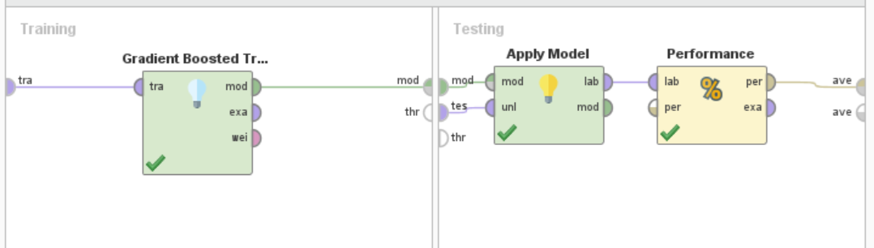

Fig. 46

#### **Decision Tree**

A decision tree consists of leaf nodes and internal nodes with branches. A leaf node represents a class while an internal node represents features. Branches represent the conjunction of features that move towards classification. The performance depends on how well it is constructed on the training set (Rustam et al., 2021).

In this model, subsets are derived from partitioning the data in a recursive manner. Data is partitioned in a way that after each split, dataset is reduced and information is increased. At each step, uncertainty is reduced by means of entropy or Gini index. Decision trees are of two types as given below:

Classification Trees: These divide the dataset into subsets based on binary variables e.g. yes or no.

Regression Trees: These divide the dataset into subsets based on numeric or categorical variables.

Decision trees are not sensitive to missing values or outliers, hence these require less efforts to prepare the dataset. Features are selected by means of Information Gain ratios. However, parameter selection in large and complex datasets becomes a cumbersome and difficult task (Hoare, 2022).

The whole process is shown in the fig. 47 below.

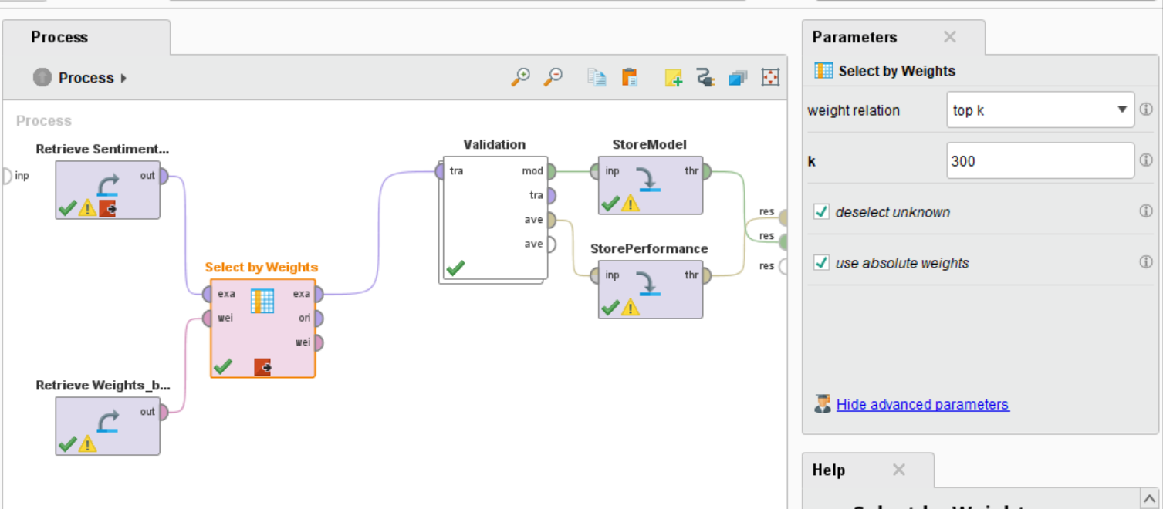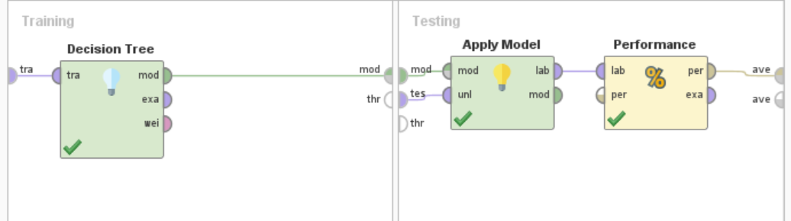

Fig. 47

#### **Support Vector Machine**

This model is based on the mechanism of building hyperplanes or boundaries that are fitted on training samples of a class. Vectors are used to classify data points into regions. The boundaries are selected based on the performance of separating the points with minimum misclassification. If data cannot be separated, a penalty is charged and the hyperplane that has minimum penalty is chosen. However, the problems with the support vector machine classifiers is that these involve high computation cost including time. Advantage of this model is that overfitting is not a problem (Hoare, 2022).

The process is shown in the fig. 48 below.

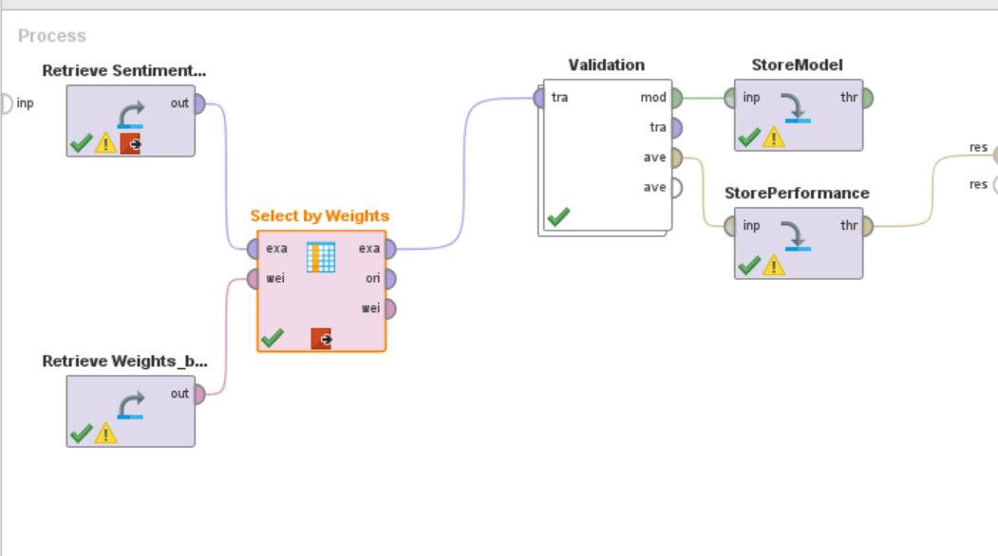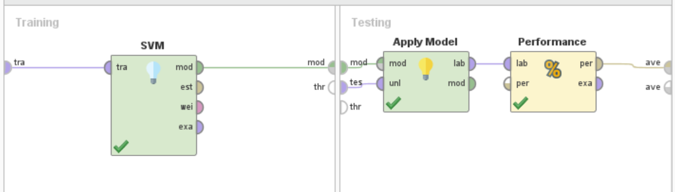

Fig. 48

#### **Naïve Bayes**

It is based on the Bayes theorem that calculates the conditional and prior probability to establish the relationship between attributes and class label. Stratified sampling techniques is applied. Training data should truly represent the population. This model does not require extensive work on preparing the data as it is not sensitive to the missing values and outliers (Hoare, 2022).

The process is as shown in the fig. 49 below.

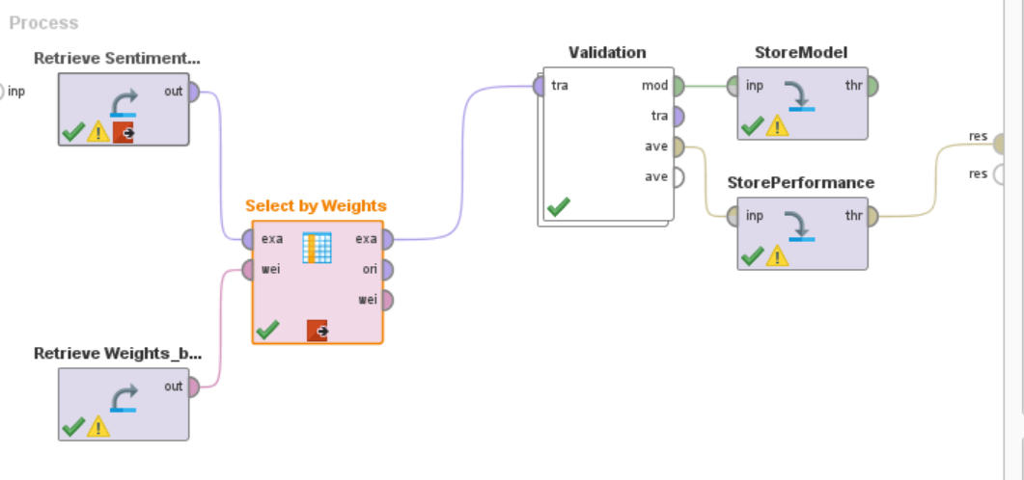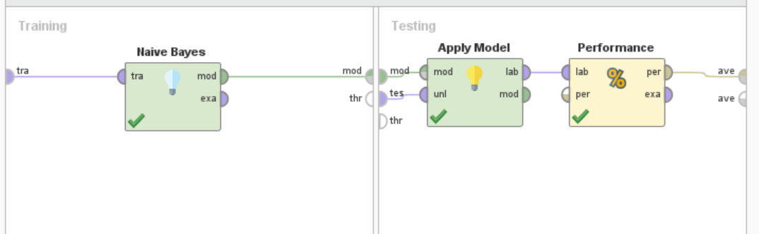

Fig. 49

#### **Generalized Linear Model**

This model is an extension of linear regression and is used where the response variable has arbitrary distribution instead of normal distribution. This allows the link function to act linearly with the predicted values (Hoare, 2022).

The whole process is as shown in the fig. 50 below.

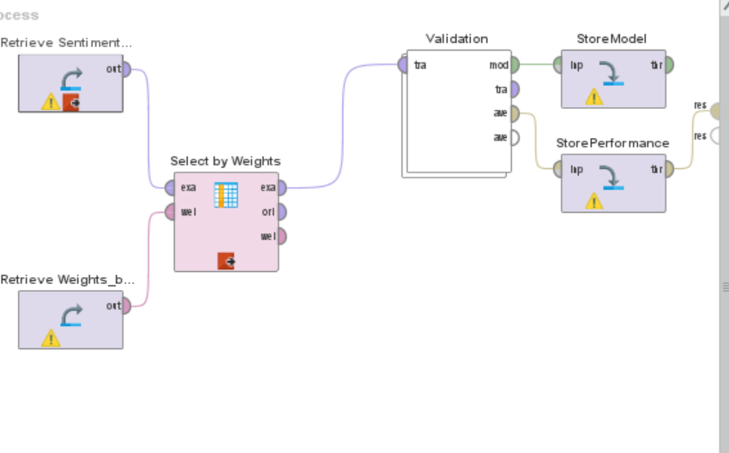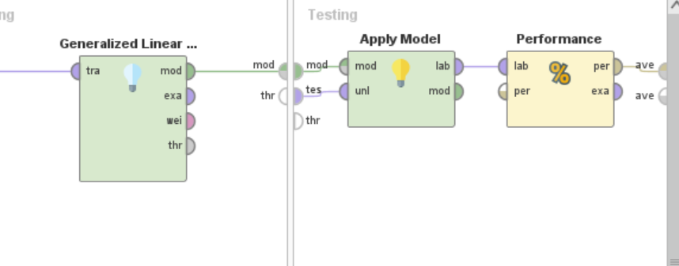

Fig. 50

#### **Deep Learning**

Deep Learning uses convolutional neural network (CNN) that uses transformation and graphs to build multi-layered model. CNN automatically detects important features. First layer extracts low level features while the last layers extract high level features. It is mostly used for speech processing, visual data processing etc. (Alzubaidi et al., 2021).

This is mostly used for the complex data or where there is non-linear relationship between input and output variables. In this model, there are hidden layers with activation functions. The activation function uses linear transformation for a certain range of value (Hoare, 2022).

The whole process is as shown in the fig. 51 below.

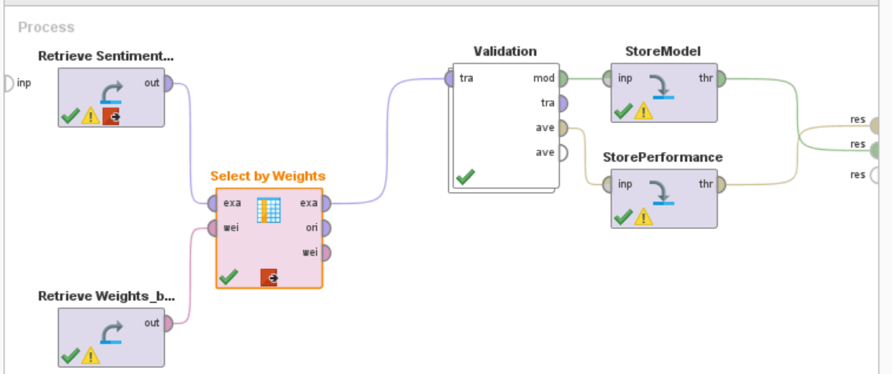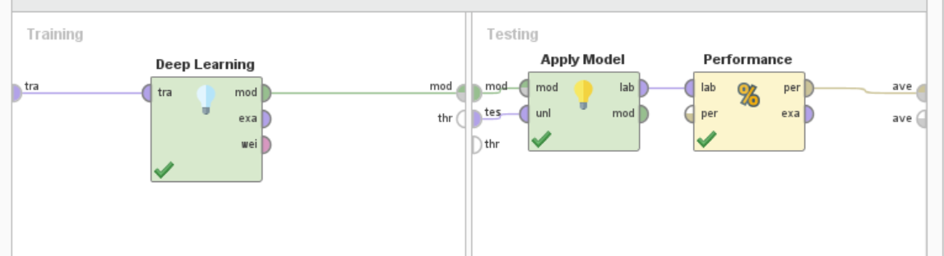

Fig. 51

# **Testing and Evaluation**

## **Process 6: Prepare the Test**

Now whatever we have done for the training of the data, the same process is to be done on test data. So as such we are going to be preparing for the test data.

From the file “Testing_Process_03_ExcelData” saved in the local folder, data is read and undergoes through the “Process Document” operator that has sub-operators of tokenization, filtering stop words, stemming, generate-n-grams and filtering tokens by length. Process document creates vector of words using term frequency. The whole process is shown the fig. 52.

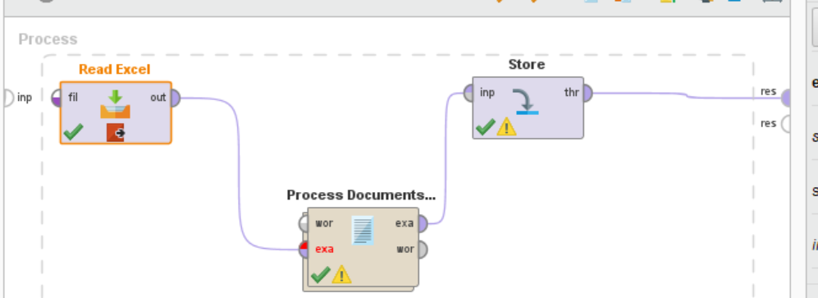

Fig. 52

The file “SentimentsCA-class-testing-docvector” is stored in the subfolder “TempCA2” of the folder “Temp” in the repository.

## **Process 7: Apply Test Process**

The model from the previous process that was stored by the name of “SentimentsCA-classifier-Voted” is retrieved. Similarly, data stored from the previous processes is retrieved from the files “SentimentCA-class-training-docvector”,“SentimentsCA-class-testing-docvector”, “Weights_by_SVM”. Here we have applied Superset operator.

**Superset**

The words used might be different from the words used in tweet, therefore we have applied the superset operator. This operator takes the two inputs (SentimentCA-class-training-docvector and SentimentsCA-class-testing-docvector), stored from the previous process 5, adds their features that results in the attributes that have different examples.

The whole process is shown in the fig. 53.

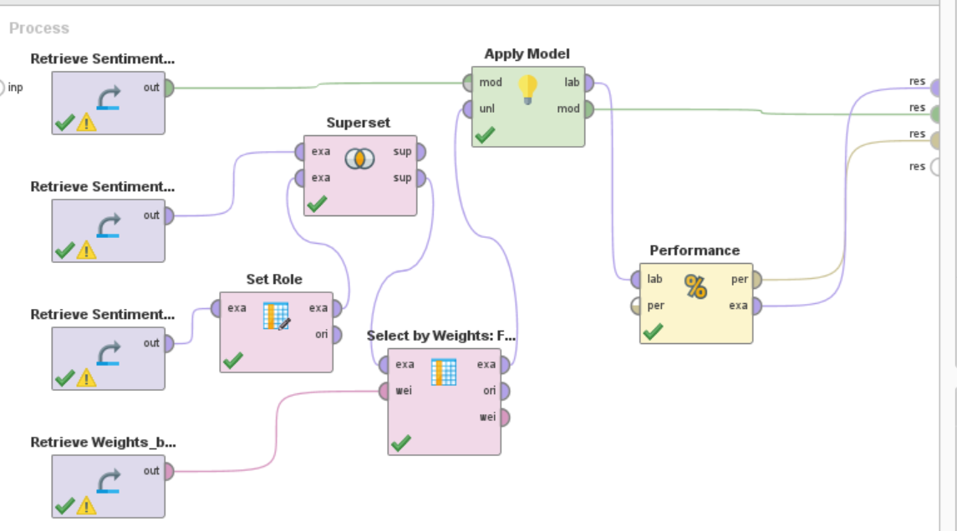

Fig.53

## **Evaluation**

### **Evaluation Metrics**

Performance metrics used are accuracy, precision, recall, AUC.

**Accuracy**

This is a measurement for correct predictions.

Accuracy= TP+TN/(TP+TN+FP+FN)

TP= True Positive. The number of correct positive predictions

TN=True Negative. The number of correct negative predictions

FP= False Positive. The number of false positive predictions

FN= False Negative. The number of false negative predictions.

(Rustam et al., 2021)

**Precision**

It measures the correctness of the classifier model (Rustam et al., 2021).

Precision= TP/ (TP+FP)

**Recall**

It shows the completeness of a classifier (Rustam et al., 2021).

Recall= TP/(TP+FN)

**AUC (Area Under the ROC Curve)**

ROC is “Receiver Operating Characteristic Curve) graph that shows recall and false positive rate. It enables to distinguish between different classes. It ranges between 0 and 1. 1 is for the good classification and 0 for the worst (Dey, 2021).

**Confusion Matrix**

It is tabular form of the visualization of the model’s predictions. Rows represent predictions, columns represent actual class (Dey, 2021). It is helpful in finding accuracy, precsion and recall.

### **Evaluation: Testing Process Result**

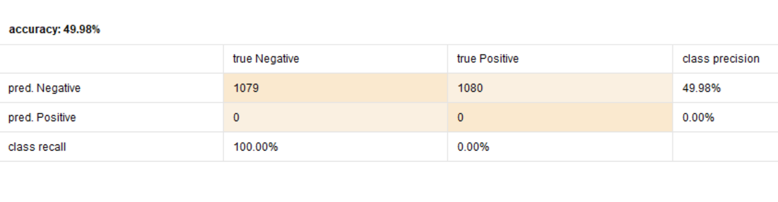

Fig. 54

### **Evaluation: Auto Model Process**

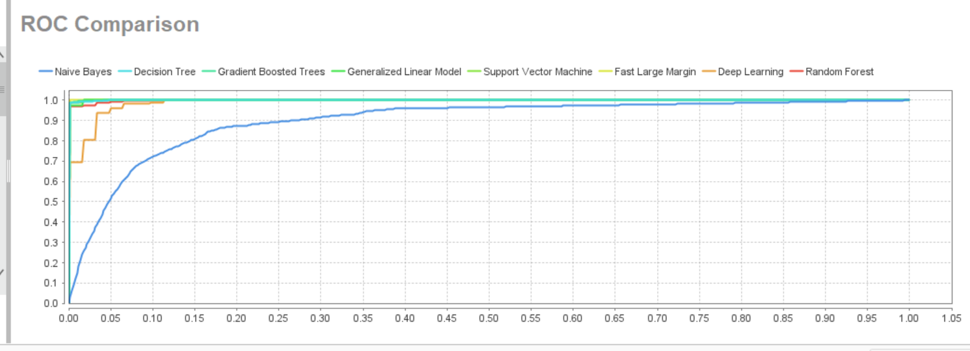

Fig. 55

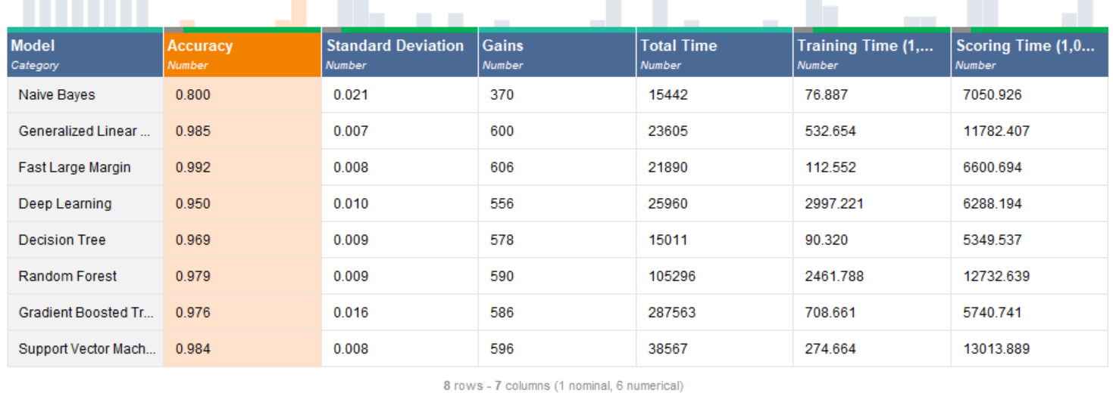

Fig. 56

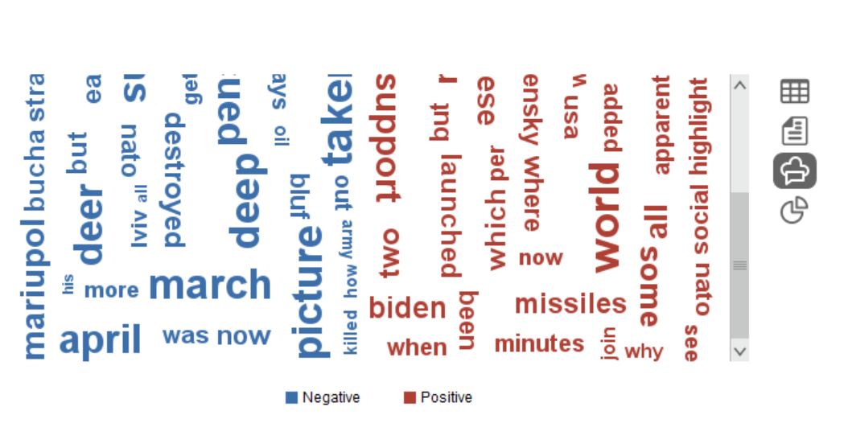

Fig. 57

### **Evaluation: Individual Classifiers Modelling**

#### **Performance Ensemble Model**

**Accuracy**

Accuracy of the applied model comes out to be 77.07% +/- 2.72% as shown in the matrix in the fig. 58.

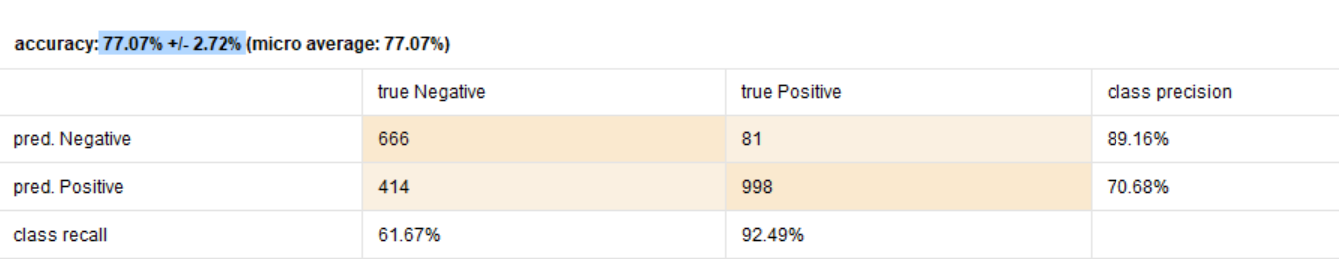

Fig. 58

**Precision**

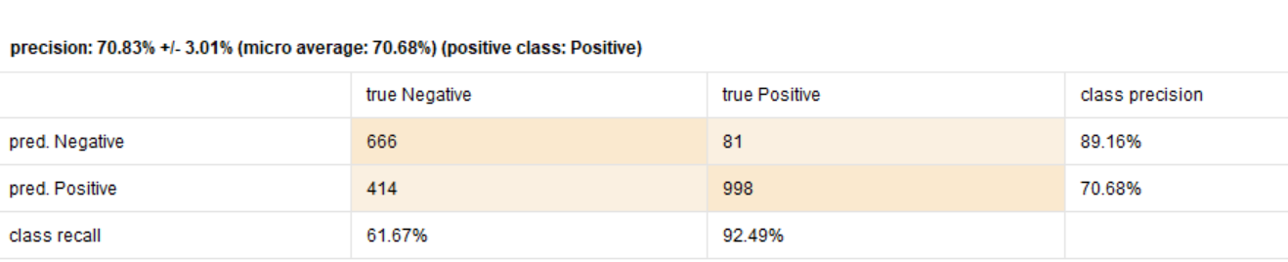

Fig. 59

**Recall**

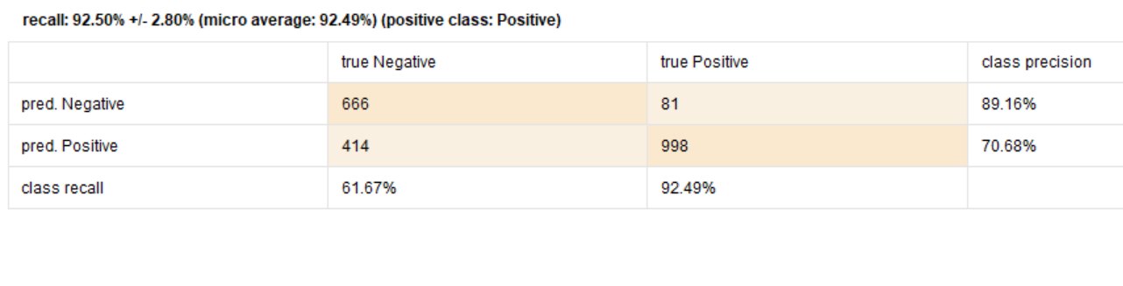

Fig. 60

**AUC**

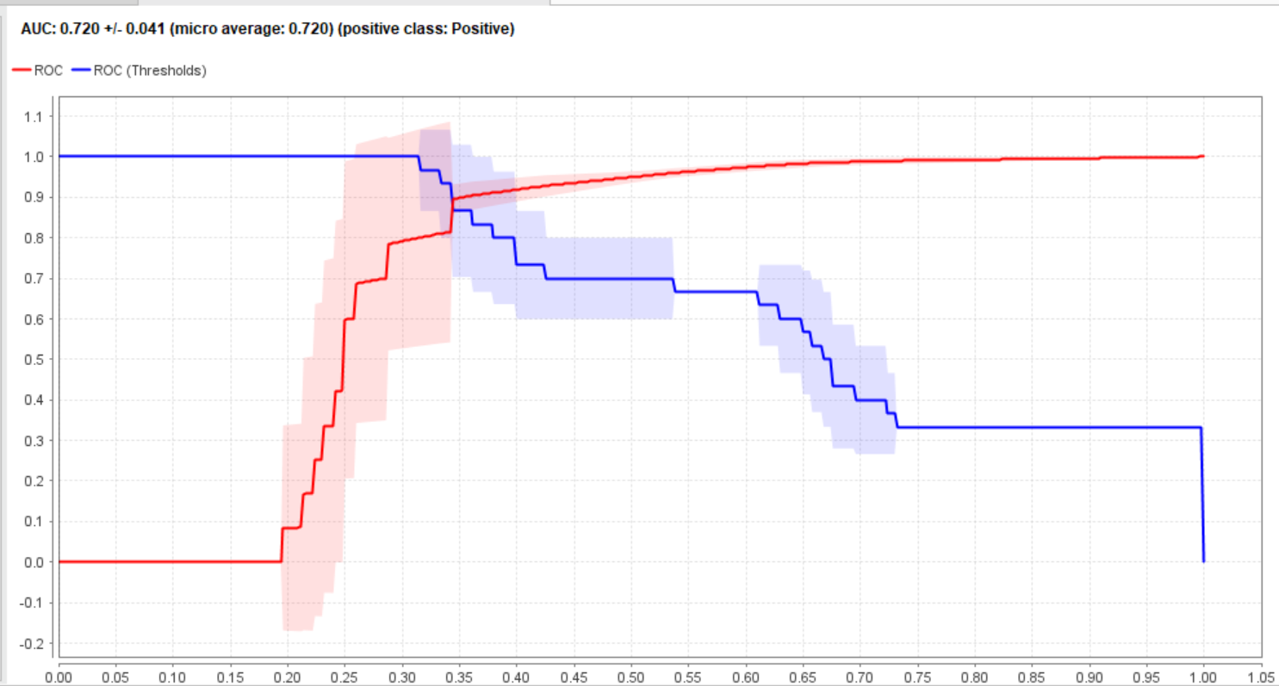

Fig. 61

The results of the three models i.e. Decision Tree, Generalized Linear Model and Deep Learning models. are described below.

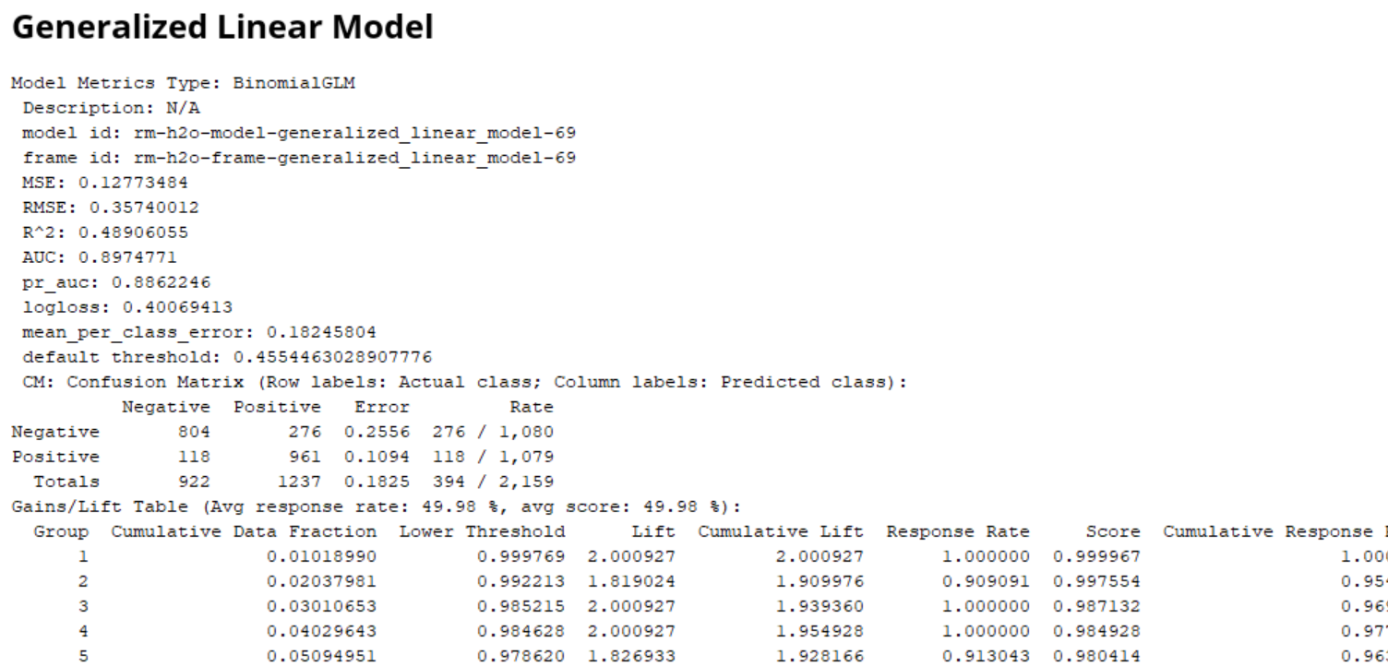

Fig. 62

**Deep Learning**

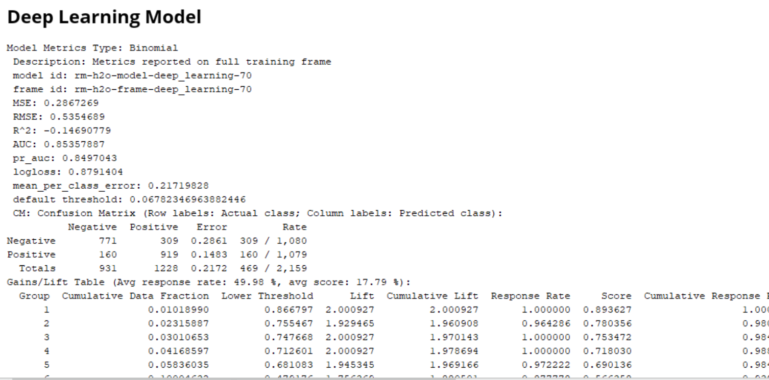

Fig. 63

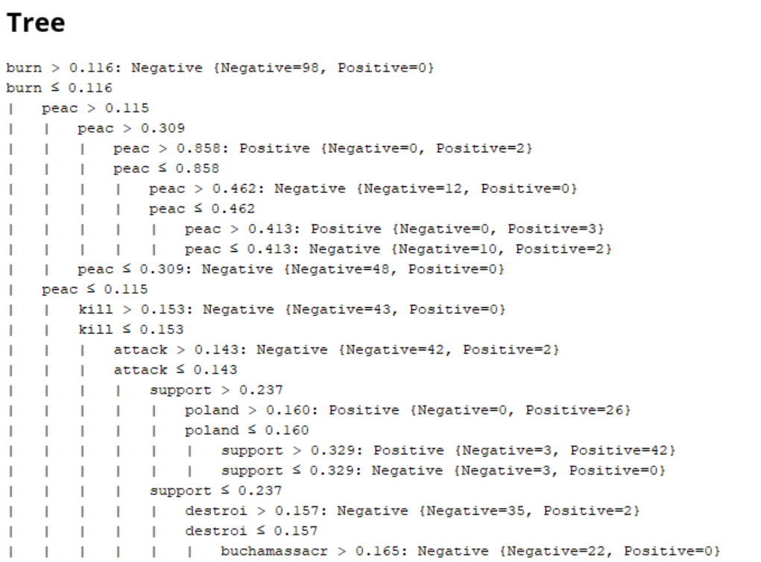

Fig. 64

#### **Performance Random Forest Model**

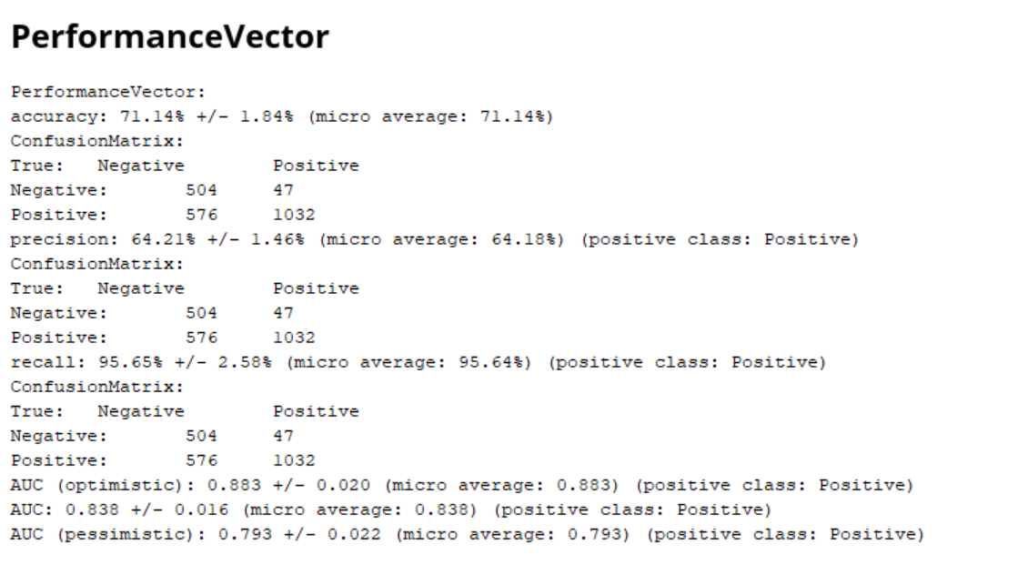

Fig. 65

**Accuracy**

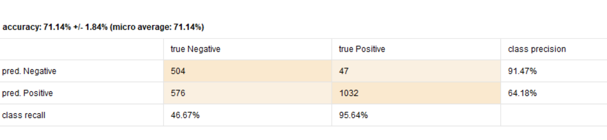

Fig. 66

**Precision**

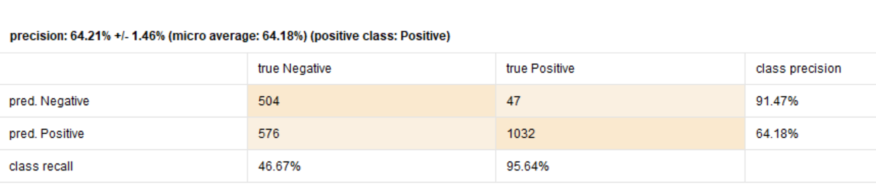

Fig. 67

**Recall**

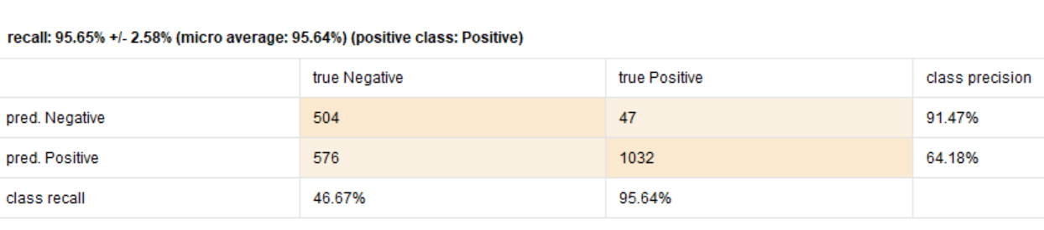

Fig. 68

**AUC**

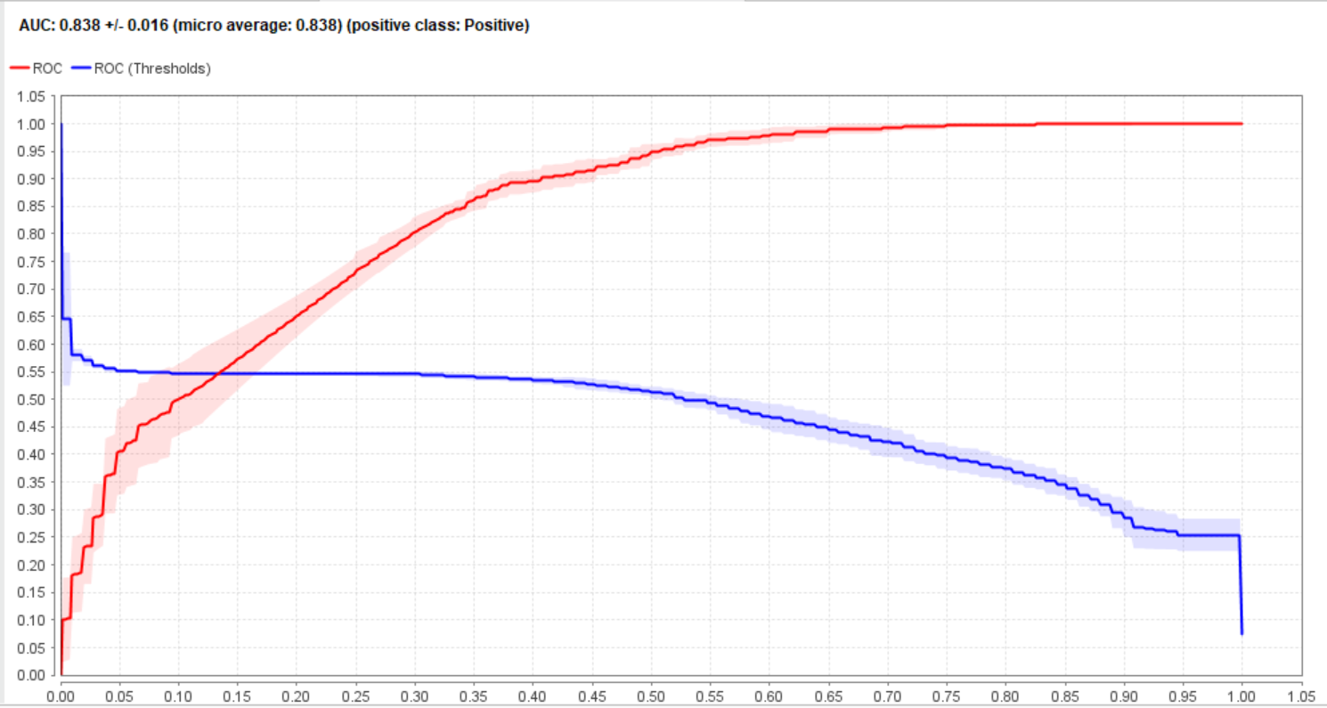

Fig. 69

#### **Performance Gradient Boosted Tree**

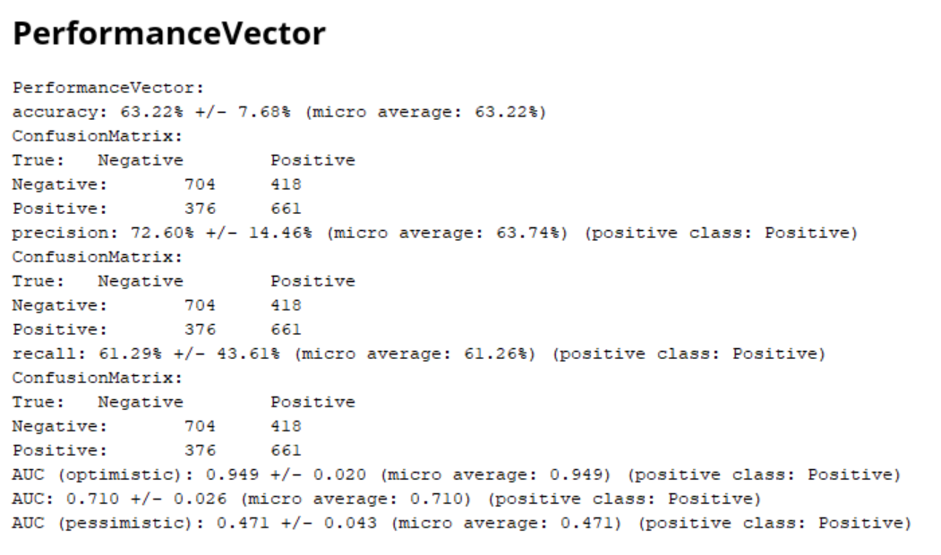

Fig. 70

**Accuracy**

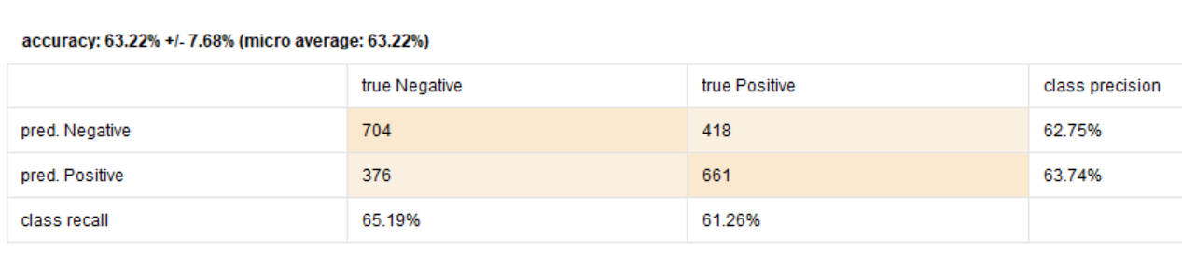

Fig. 71

**Precision**

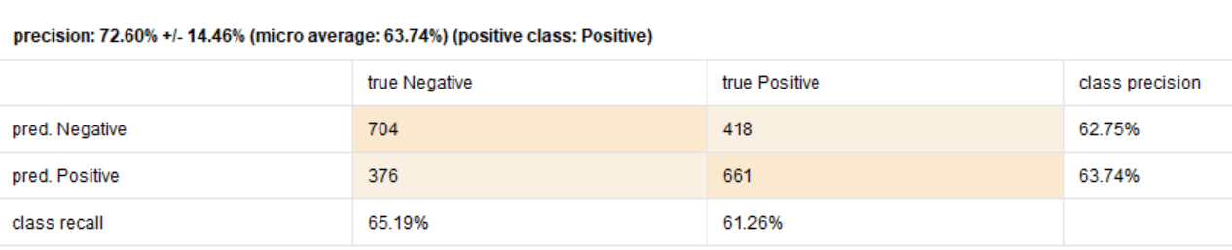

Fig. 72

**Recall**

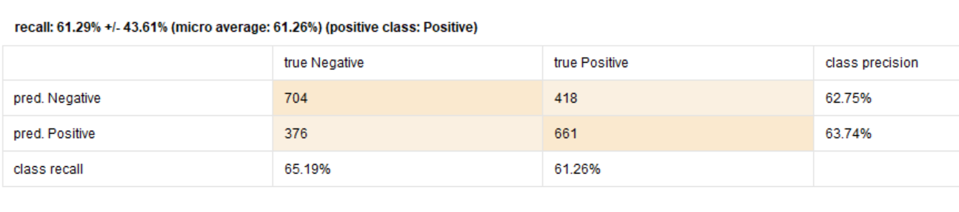

Fig. 73

**AUC**

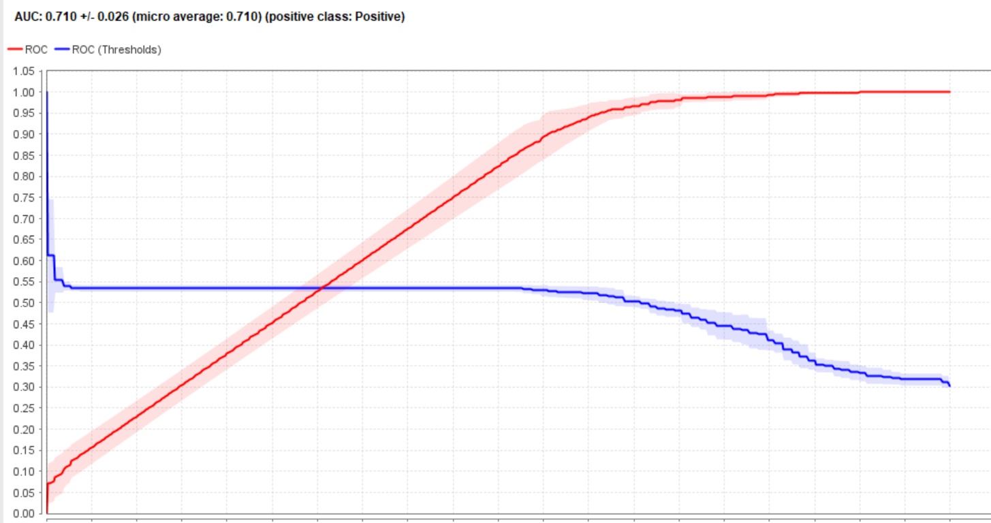

Fig. 74

#### **Performance Decision Tree**

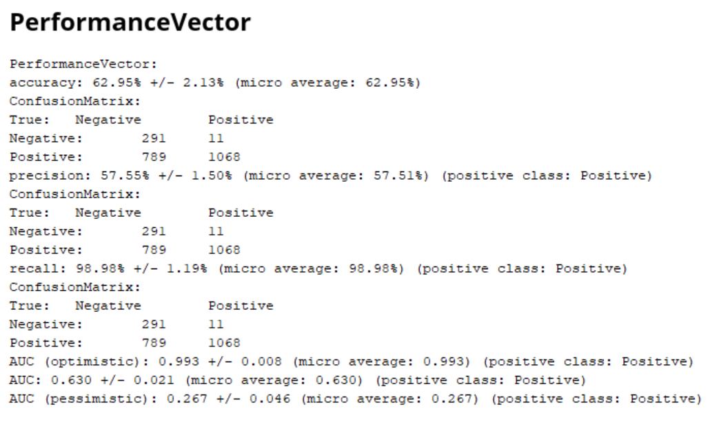

Fig.75

**Accuracy**

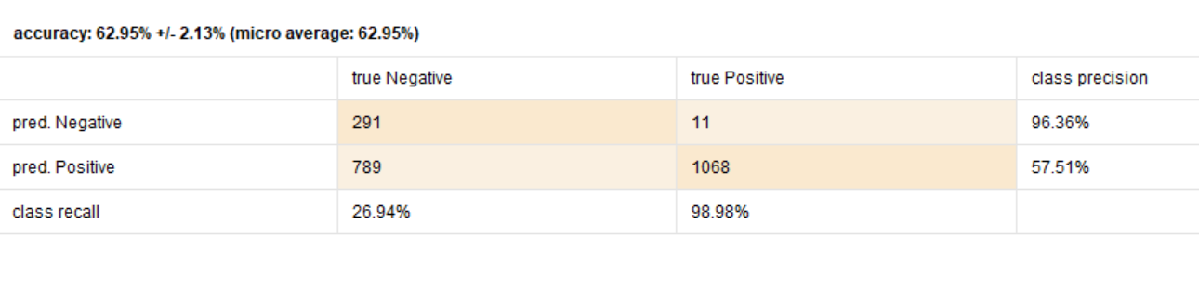

Fig. 76

**Precision**

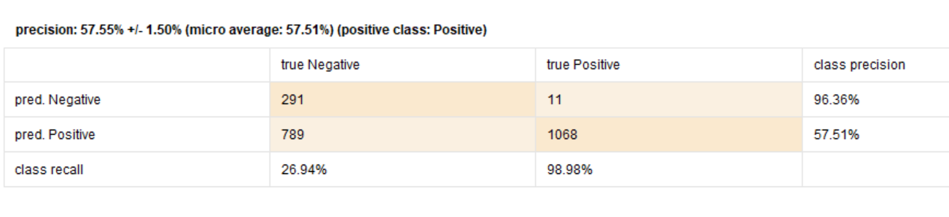

Fig. 77

**Recall**

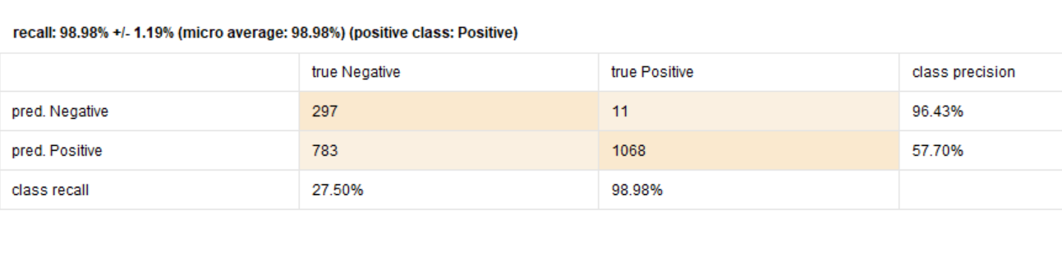

Fig. 78

**AUC**

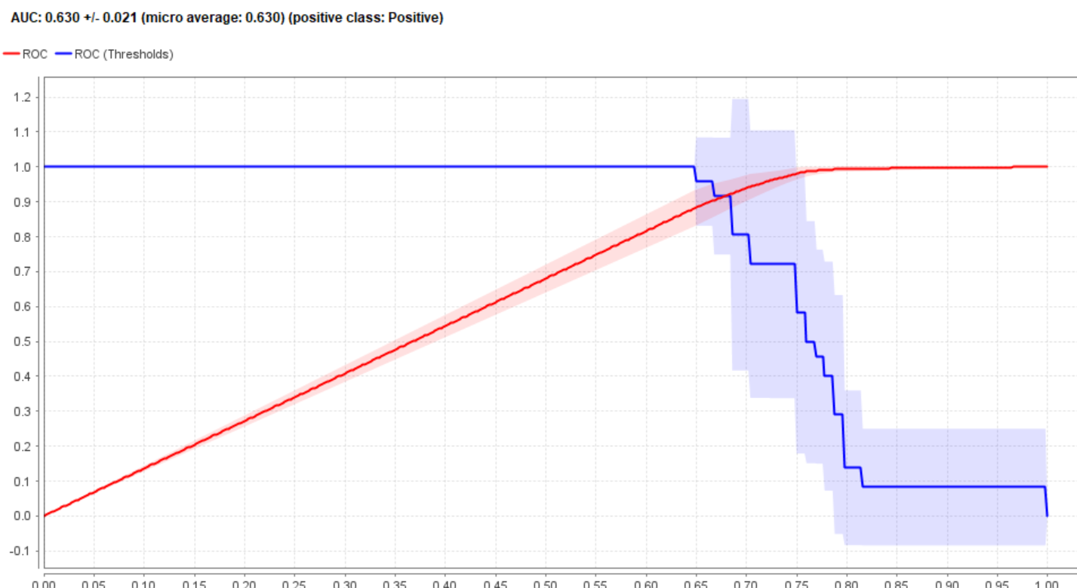

Fig. 79

#### **Performance Support Vector Machine**

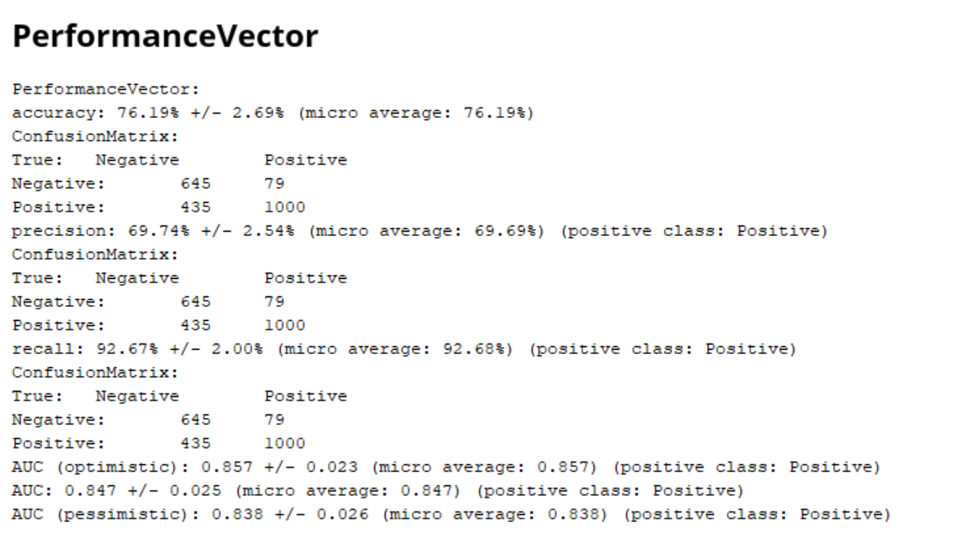

Fig. 80

**Accuracy**

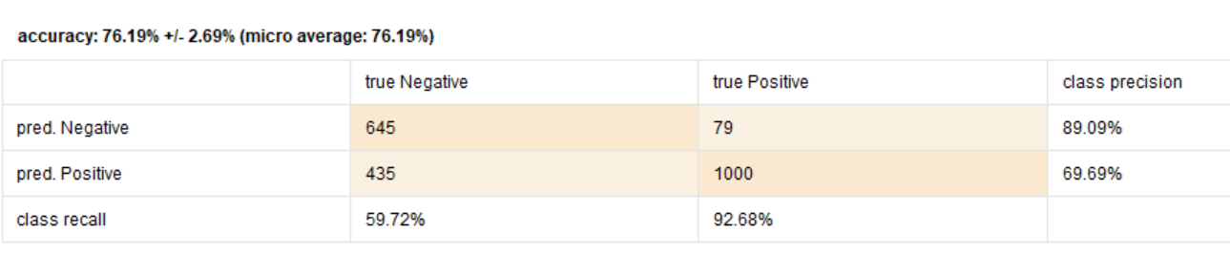

Fig. 81

**Precision**

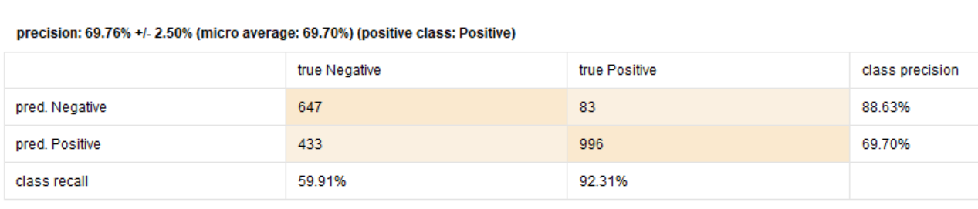

Fig. 82

**Recall**

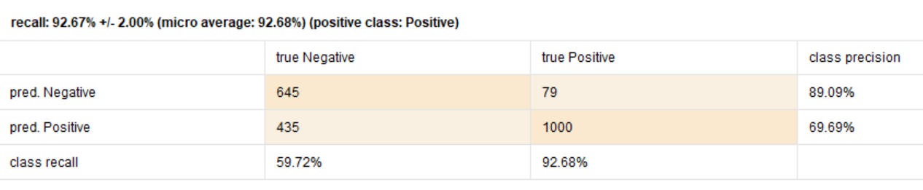

Fig. 83

**AUC**

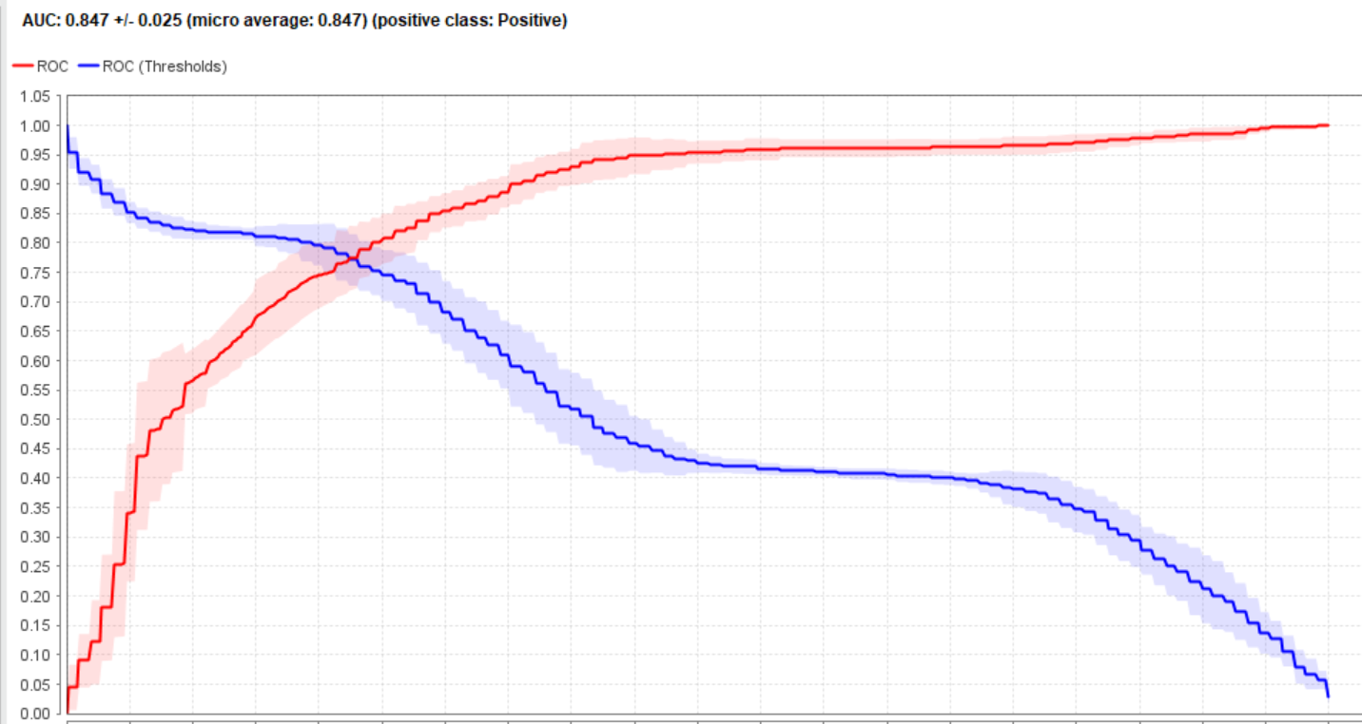

Fig. 84

#### **Performance Naïve Bayes**

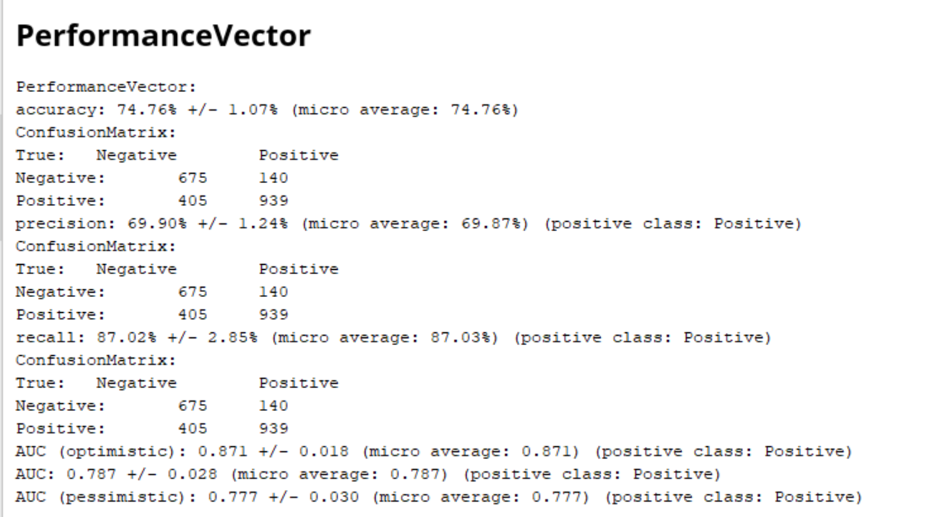

Fig. 85

**Accuracy**

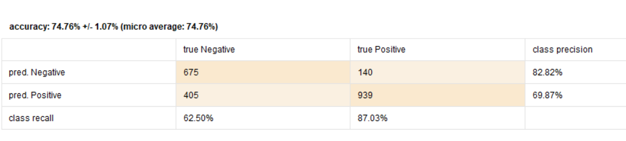

Fig. 86

**Precision**

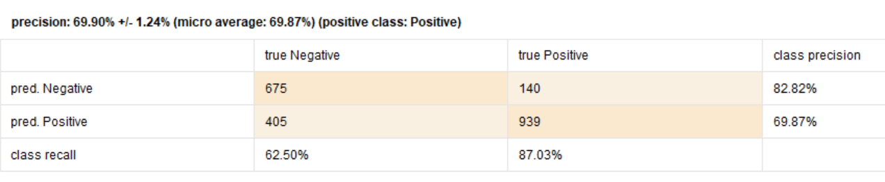

Fig. 87

**Recall**

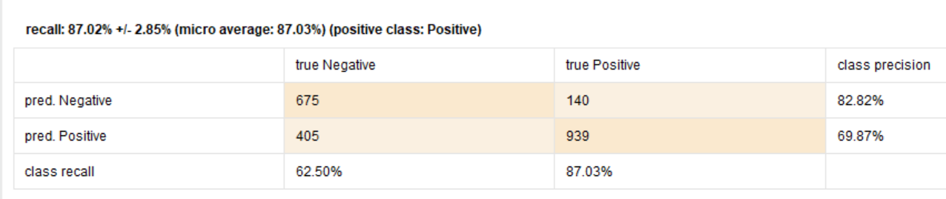

Fig. 88

**AUC**

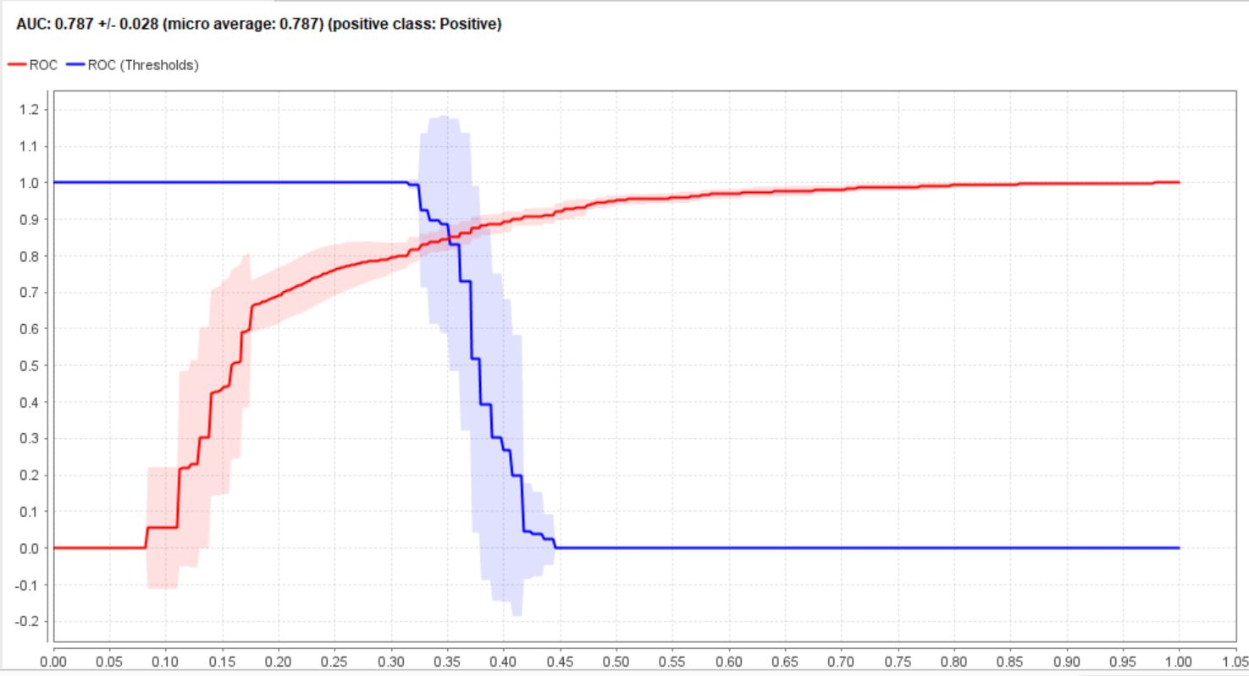

Fig. 89

#### **Performance Generalized Linear Model**

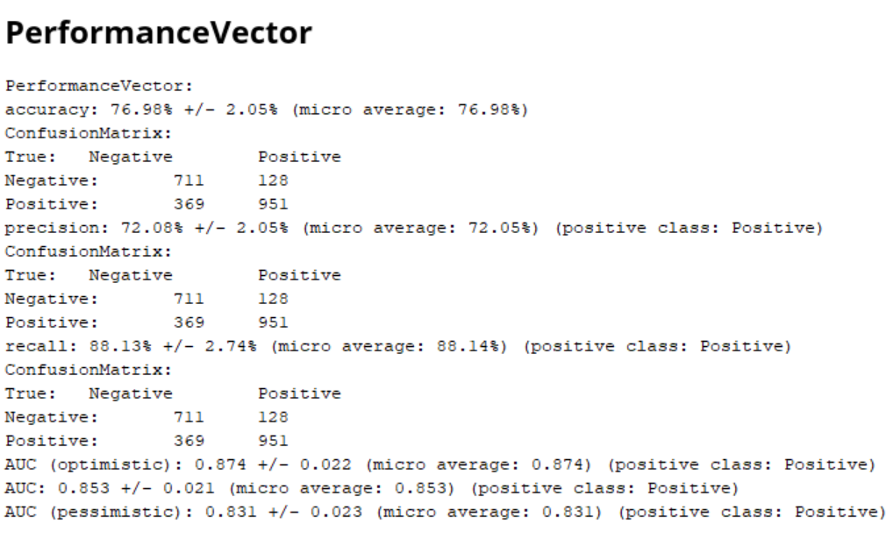

Fig. 90

**Accuracy**

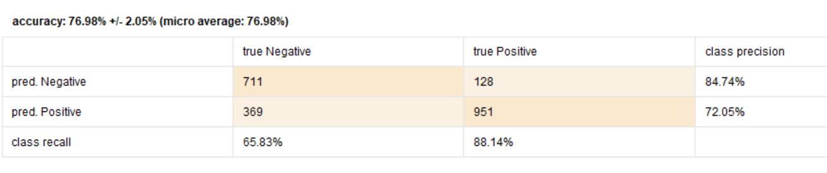

Fig. 91

**Precision**

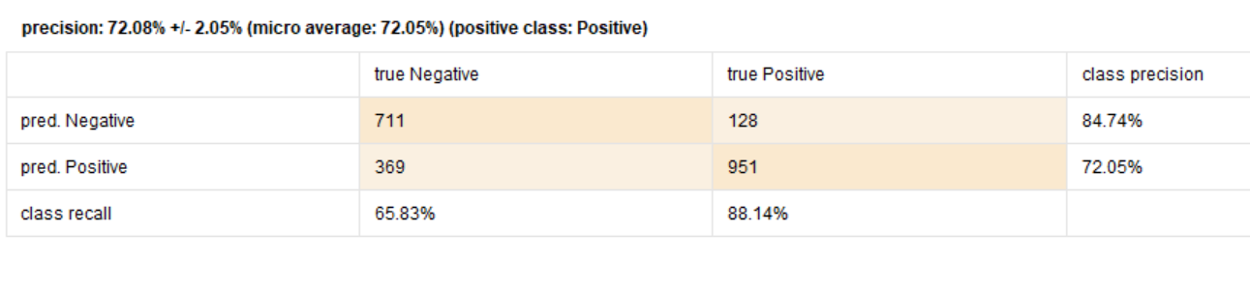

Fig. 92

**Recall**

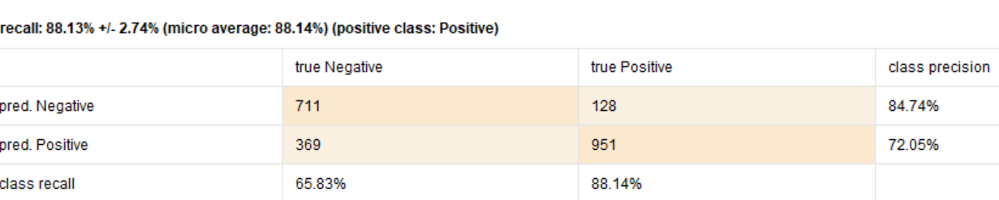

Fig. 93

**AUC**

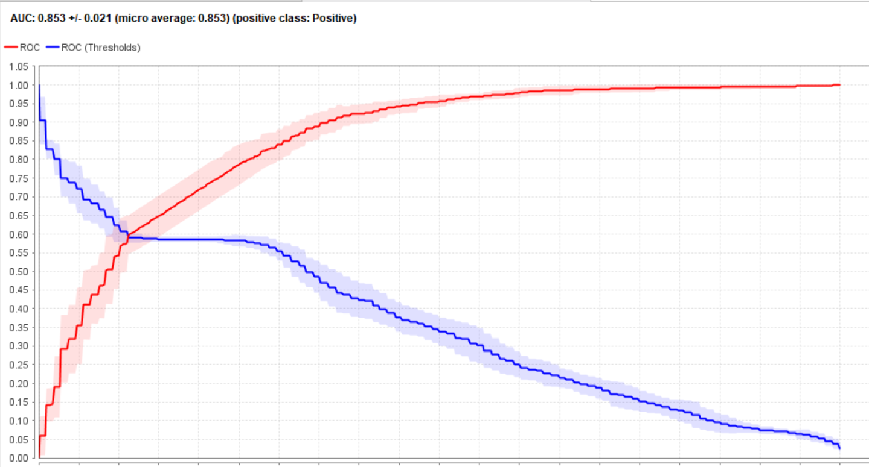

Fig. 94

#### **Performance Deep Learning**

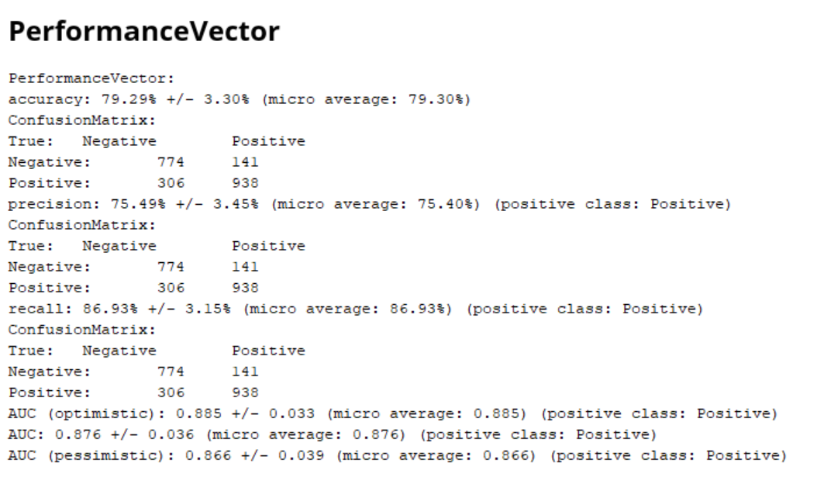

Fig. 95

**Accuracy**

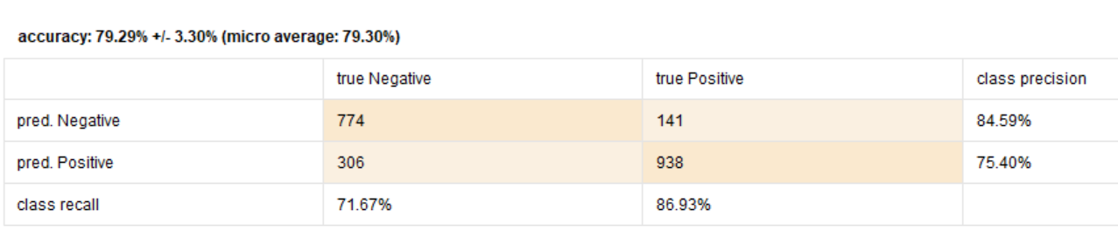

Fig. 96

**Precision**

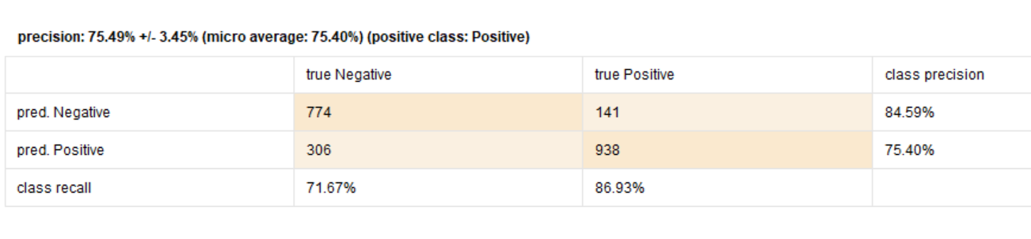

Fig. 97

**Recall**

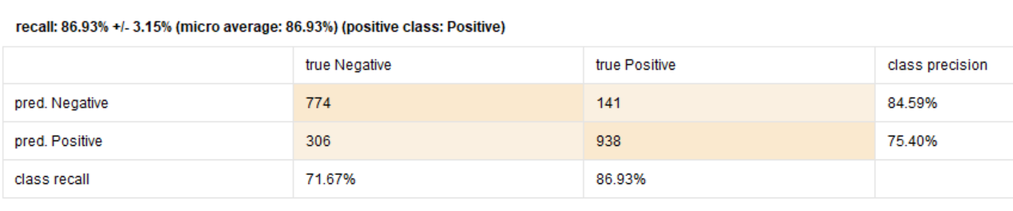

Fig. 98

**AUC**

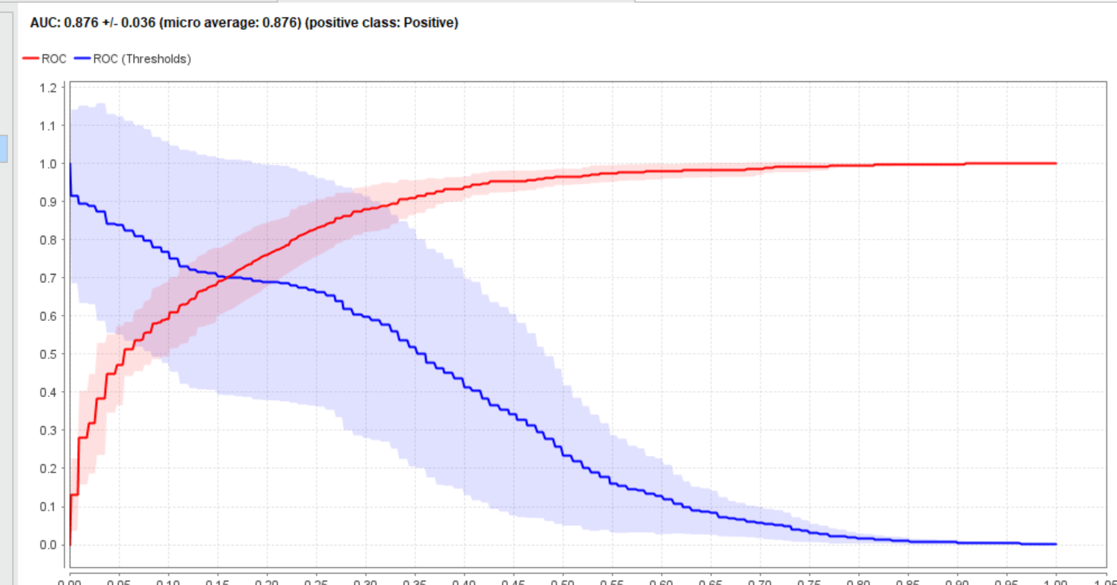

Fig. 99

### **Evaluation: Modelling by Python**

|  |  |  |  |
| --- | --- | --- | --- |
| Models | Accuracy | Precision | Recall |
|  |  |  |  |
| GLM | 98 | 98 | 98 |
| Deep Learning | 99 | 50 | 100 |
| Decision Tree | 100 | 100 | 100 |
| Random Forest | 100 | 100 | 100 |
| Gradient Boosted Tree | 100 | 100 | 100 |
| Support Vector Machine | 99.60 | 100 | 100 |
| Naïve Bayes | 98 | 98 | 98 |

**Table 1**

# **Deployment**

For the web services, these developed models are easy to deploy. Web services can serve for the real time prediction of sentiment analysis. However, there could be the problem of waiting and system hanging as there are a large number of tweets.

Demand prediction or batch prediction is the most preferable method to reduce the computation cost and to avoid the issues that are faced in web services deployment. This method is also easy to troubleshoot.

There are cloud services like Microsoft azure, AWS machine learning services on which the system can be deployed. An API can then be developed available for business use. Anyone can use that application on their own system and benefit from it.

Another method is to use embedded models. We can easily deploy the model on device. However, the only drawback is that device needs to have enough computing power and storage to execute the model.

All in all a batch prediction method is the most convenient method of the deployment.

**Findings and Recommendations**

Because the data is taken from Kaggle and it was in excel or csv format, therefore, most of emojis from tweets could not be scored because those were not in text form. If data is taken directly from the twitter, then in that case, the developed models would serve the purpose of real time sentiment analysis of the tweets. However, in the current case, because of the limitation of the data being taken from Kaggle, the models developed are unable to generalize as evident from the evaluation performance of “testing”.

As a result, the developed models will work well and would have a real time performance in case when data is taken directly from twitter.

**Validation of the models**

Auto-model evaluation performance has shown good performance of all the models. Among all the models, support vector machine and Generalized Linear Model are on the top. However, as shown in the figure. 56, support vector machine model is time consuming and for the real time application, this could be a problem.

However, the evaluation performance of manually developed models on the RapidMiner is lower as compared to Auto-model evaluation performance. This is because of the problem due to the limitation of the models being unable to generalize due to data preparation and pre-processing limitations.

In case of the individual modelling manual development on the RapidMiner, Deep Learning model and Ensemble models have performed well.

In case of models developed by Python, all models have performed well. This is because we have taken the cleaned and pre-processed data whose polarities are already generated.

# **Conclusion and My Learning**

The war between Russia and Ukraine is of great concern for everyone. It has brought about inflation throughout the world. It may lead to another world war if proper strategy is not adopted to curb the situation. In this study, sentiment analysis is done using supervised machine learning models.

The results of the auto-model are summarized in the table 2 given below:

|  |  |  |  |  |
| --- | --- | --- | --- | --- |
| Models | Accuracy | Precision | Recall | AUC |
|  |  |  |  |  |
| GLM | 98.55 | 97.19 | 100 | 1 |
| Deep Learning | 94.99 | 91.16 | 99.68 | 0.99 |
| Decision Tree | 96.92 | 94.23 | 100 | 1 |
| Random Forest | 97.90 | 97.16 | 98.70 | 0.99 |
| Gradient Boosted Tree | 97.57 | 95.45 | 100 | 1 |
| Support Vector Machine | 98.38 | 96.89 | 100 | 1 |
| Naïve Bayes | 80.44 | 74.22 | 92.22 | 0.89 |

Table 2

The performance results of the individual models applied are summarized in the table 3.

|  |  |  |  |  |
| --- | --- | --- | --- | --- |
| Models | Accuracy | Precision | Recall | AUC |
| Ensemble | 77 | 70.8 | 92.50 | 0.72 |
| GLM | 76.98 | 72.08 | 87.13 | 0.852 |
| Deep Learning | 79.29 | 75.49 | 86.93 | 0.87 |
| Decision Tree | 62.95 | 57.75 | 98.98 | 0.63 |
| Random Forest | 71 | 64.2 | 95.64 | 0.843 |
| Gradient Boosted Tree | 63.22 | 72.60 | 61.29 | 0.71 |
| Support Vector Machine | 76.19 | 69.78 | 75 | 0.847 |
| Naïve Bayes | 74.78 | 69.90 | 87.02 | 0.787 |

Table 3

As can be seen from the table 2 and table 3, models performed better in case of auto-model as compared to the performance of the individual models.

In case of auto-model, generalized linear model, random forest and support vector machine performs well in terms of accuracy and precision.

As far as the individual model performance is concerned, the performance of all models is almost similar except for the decision tree and gradient boosted trees, whose performance is not as good as the rest of the models.

As shown in the fig. 56, performance result from auto-model, gradient boosted tree and random forest model are time consuming models as compared to the others.

As these are the sentiments, people usually write in words that have different meaning. This could be an issue in predicting the correct polarity.

There are various emojis in tweet that were converted to UTF-code in the provided dataset of Kaggle. These emojis could not be replaced by the exact words for emotions. Although these non-word characters were not considered in modelling on RapidMiner, this compromised the exact scoring rate.

Besides emojis, there are tweets in the dataset that are not in English language. That needed to be converted into English for the RapidMiner to correctly analyse the meaning of tweets and accordingly extract score and sentiments. This also affected the performance of the individual models applied manually.

# **Reference**

Alzubaidi, L., Zhang, J., Humaidi, A., J., Al-Dujaili, A., Duan, Y., Al-Shamma, O., Santamaria, J., Fadhel, M., A., Al-Amidie, M. and Farhan, L. (2021) ‘Review of Deep Learning: concepts, CNN architecctures, challenges, applications, future directions’, *Journal of Big Data*, 53(2021), pp. 1-74. Doi: 10.1186/s40537-021-00444-8.

Dey,V. (2021)’Understanding the AUC-ROC Curve in Machine Learning Classification’,*Developers Corner,*Available at: <https://analyticsindiamag.com/understanding-the-auc-roc-curve-in-machine-learning-classification/>

Dutta, A. (2022) ‘Twitter Sentiment analysis, Russia Ukraine Conflict’, *Kaggle.*  Available at: <https://www.kaggle.com/code/avinandandutta/twitter-sentiment-analysis-russia-ukraine-conflict/data>

Ghosh, S. and Roy, A. (2022) ’Social Media Sentiment Analysis based on Russo-Ukrainian War’, *Research Gate*, pp. 1-5. Doi: [10.13140/RG.2.2.27245.05605](http://dx.doi.org/10.13140/RG.2.2.27245.05605)

Hoare, T. (2022) ‘Data Mining: Modelling Classification’, *B9DA110_2122_TMD3: Advanced Data and Network Mining*, Dublin Business School, May 2022, Available at: <https://elearning.dbs.ie/pluginfile.php/1566004/mod_resource/content/0/Supervised%20Learning%20Classification%20Algorithms.pdf>.

Hoare, T. (2022) ‘Data Mining Regression’, *B9DA110_2122_TMD3: Advanced Data and Network Mining*, Dublin Business School, May 2022, Available at: https://elearning.dbs.ie/pluginfile.php/1567099/mod_resource/content/0/Supervised%20Learning%20-%20Regression%20Algorithms.pdf

Redhu, S., Srivastava, S., Bansal, B. and Gupta, G. (2018) ’Sentiment Analysis Using Text Mining: A Review’*, International Journal on Data Science and Technology*, 4(2), pp. 49-53. Doi: 10.11648/j.ijdst.20180402.12

Rustam, F., Khalid, M., Aslam, W., Rupapara, V., Mehmood, A. and Choi, G. S. (2021) ‘A performance comparison of supervised machine learning models for Covid-19 tweets sentiment analysis’, *Plos One,* 16(2). Doi: [10.1371/journal.pone.0245909](https://doi.org/10.1371/journal.pone.0245909)

Shim, J., Ryu, K., Lee, S., H., Cho, E., Lee, Y., J. and Ahn, J., H. (2021) ‘Text Mining Approaches to Analyze Public Sentiment Changes Regarding COVID-19 Vaccines on Social Media in Korea’, *National Library of Medicine,* 18(12), pp.1-9. Doi: [10.3390/ijerph18126549](https://doi.org/10.3390%2Fijerph18126549)

Zhang, Z. (2020)’ GBDT-MO: Gradient-Boosted Decision Trees for Multiple Outputs’, *IEEE Transaction on Neural Networks and Learning Systems,*32(7), pp. 3156-3167, Doi: [10.1109/TNNLS.2020.3009776](https://doi.org/10.1109/TNNLS.2020.3009776)